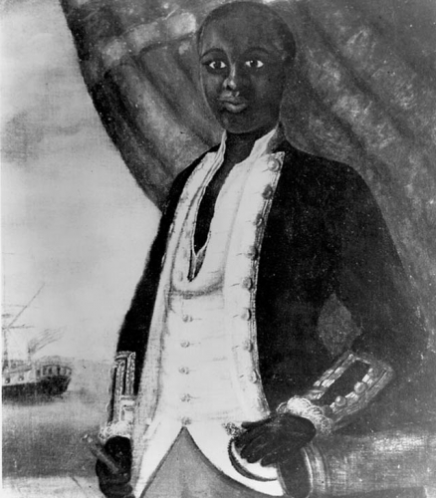
Your task is to conduct research on one African-American soldier who fought during the Revolutionary War.
Among the Patriots, choose one of the following soldiers: Crispus Attackus, Colonel Louis Cook, Jack Sisson, William Flora, James Armistead, Oliver Cromwell, Salem Poor, Prince Hall, Lemuel Haynes, Prince Esterbrooks.
Among the Loyalists, choose one of the following soldiers: Colonel Tye Titus Cornelius, Thomas Peters, Boston King, Henry Washington.
Your mission is to write a 2 page report addressing the following questions:
- What was the person's background?
- What was the role that he played in the American Revolution?
- What were his reasons to become a soldier?
- Was he a free man or an enslaved African-American?
- Who did he side with, Patriots or Loyalists?
- What were the benefits and the consequences of being on that side?
- Was he forced into the war?
- How was he treated? What were his living conditions like?
- How did the Revolution affect his life?
- Did he help the efforts to abolish slavery? If so, how?

