Affirmative Action
-Very controversial civil rights policy
- Favoring members of disadvantaged groups who suffer or have historically suffered discrimination within a culture
- Other nations have versions of affirmative action programs
- Such programs are illegal in the UK, as it doesn’t treat races equally
- Purpose was to increase minority students, employees, elected officials, etc.
- Many white Americans were opposed to Affirmative Action
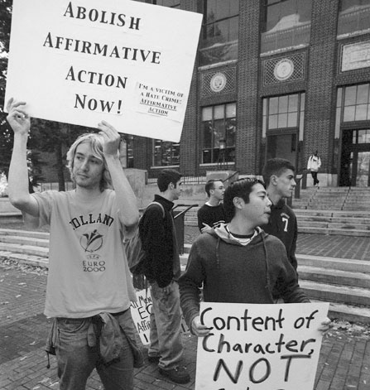
- They viewed it as “reverse discrimination”
- Less emphasis on qualifications and more emphasis on other factors
- White women benefitted from Affirmative Action
- AA community was divided on the issue
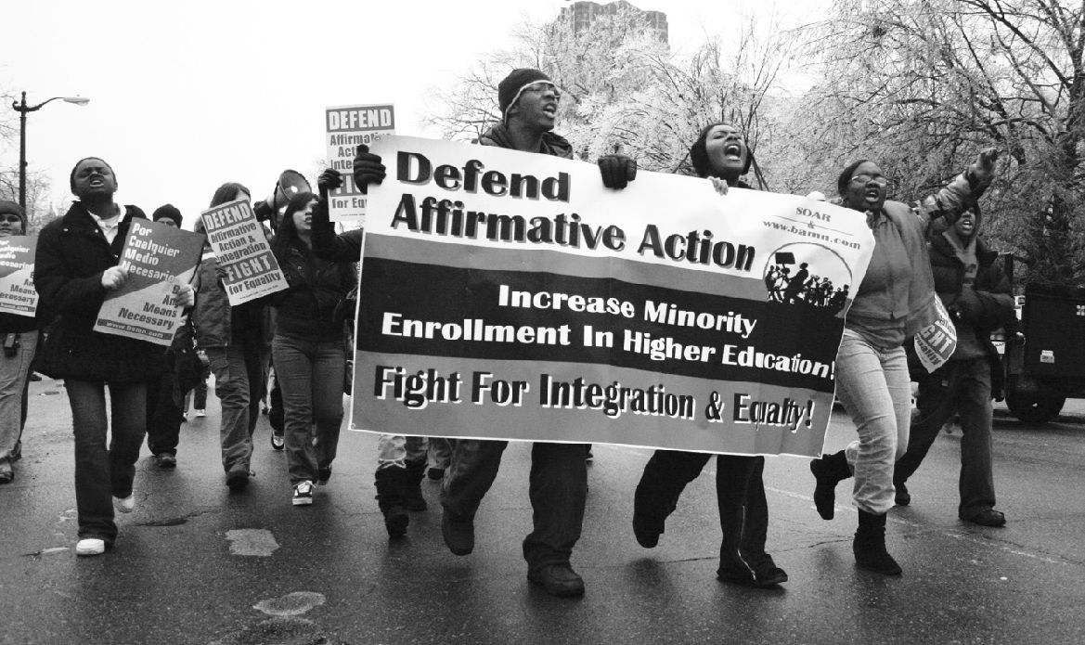
- JFK launched an executive order in 1961 preventing discrimination based on race
- Term was first used by LBJ in 1965
- He also expanded the program to include gender
- Guaranteed job seekers and employees aren’t discriminated against
- Philadelphia Plan: firms w federal gov’t contracts in construction industry would have to meet hiring goals for AAs
- Set aside programs reserved contracts for women and minority groups
The Backlash
- Through the 1970s colleges used different criteria to admit minority students
- University of California medical school reserved 16 of 100 spots for disadvantaged or minority students
- 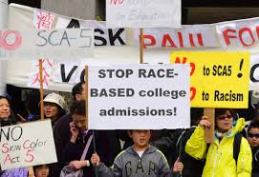

- A white student sued the university for discrimination
- Appealed all the way to the Supreme Court
- Ruled that the student’s rights were violated
Rooney Rule
- National Football League policy which requires minorities to be interviewed for head coaching positions
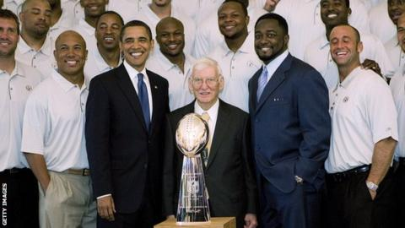
- There is no quota system
- Teams aren’t required to hire minority candidates
- Created in reaction to 2 AA coaches being fired in 2002 (Dungy and Green)
- Prior to the Rooney rule there had been 6 minority coaches
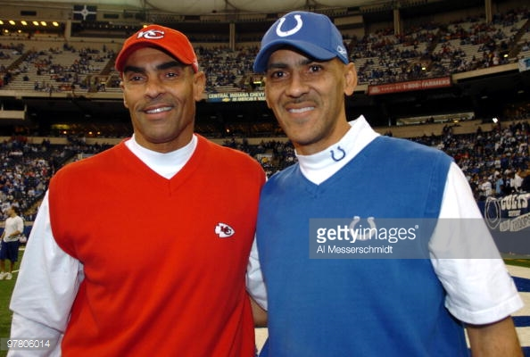
- Post 2003 there have been 14, including 5 who are active
