Bacon’s Rebellion
- Colonists accepted class division as long as they believed the gov’t ruled for everyone’s good
- This rebellion erupted in 1676
- The dispute was over Virginia’s Indian policy
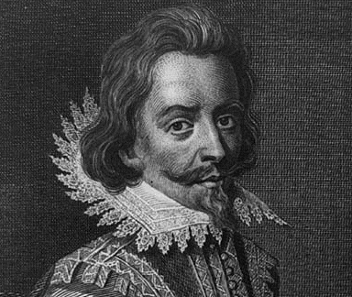
- Left a legacy of hostility between plantation owners and their poorer neighbors
- The Algonquin tribe mounted a surprise attack in 1644
- Roughly 500 colonists were killed
- Fighting lasted for almost 2 years
- Colonists were ultimately successful
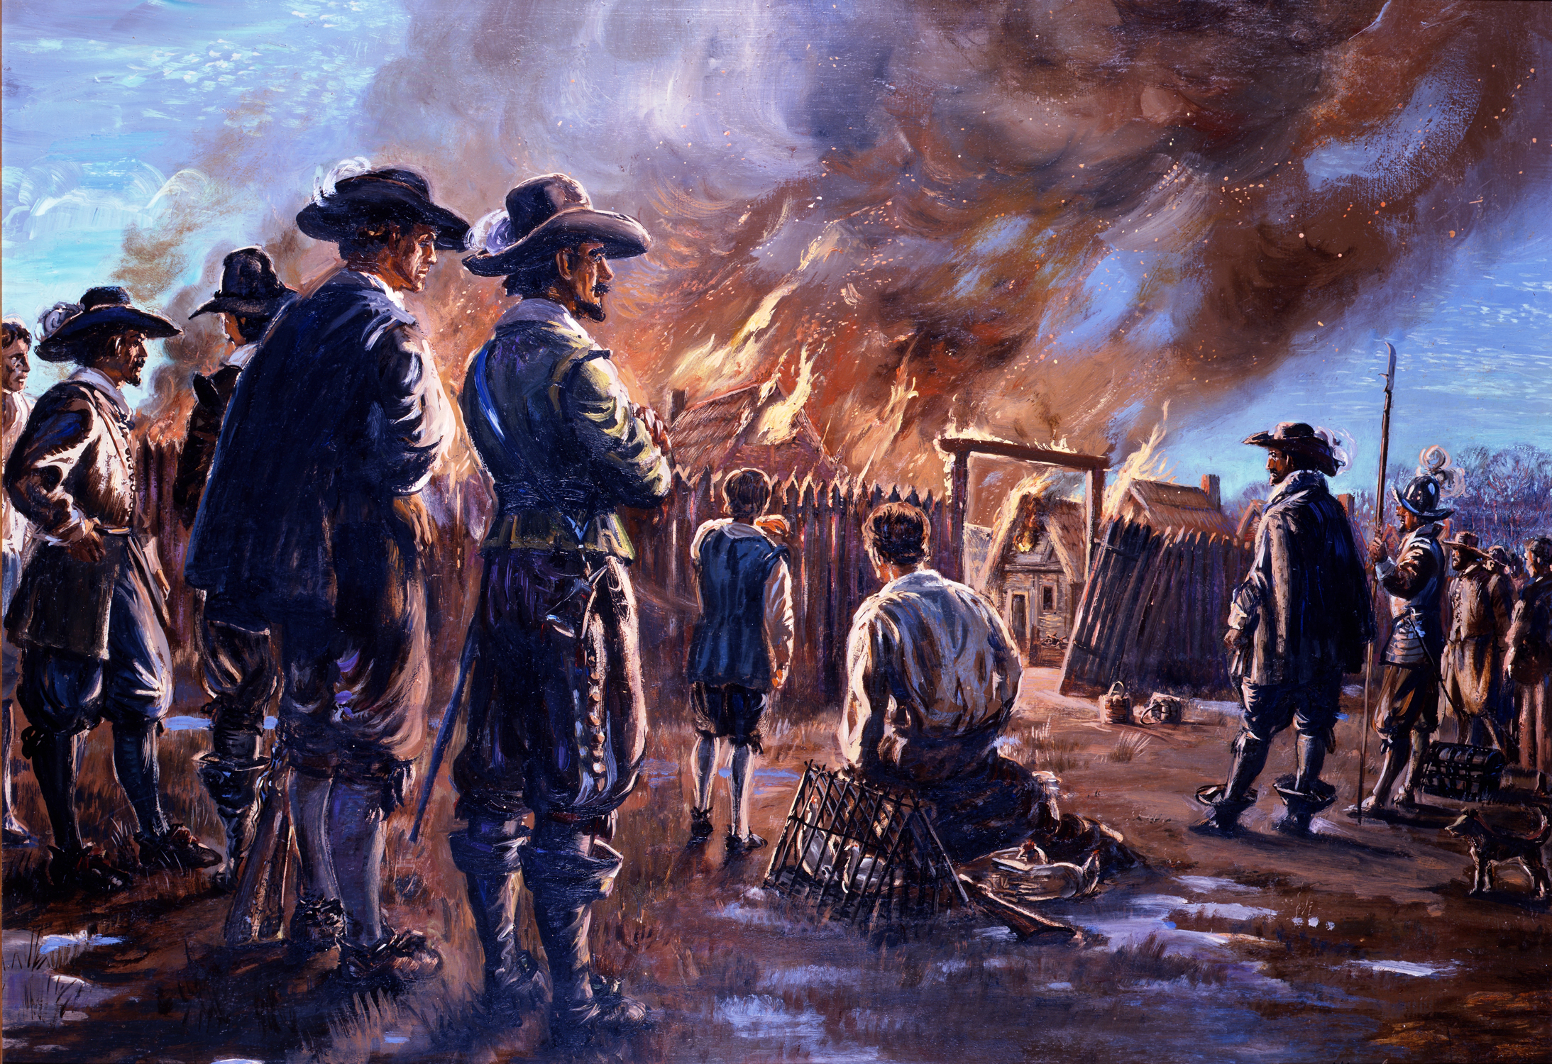
- Indians were forced to relinquish land settled by the British
- Wilderness beyond settlements was supposed to be reserved for Indians
- Chesapeake population steadily grew
- Between 1660-1670 violence between colonists and Indians increased
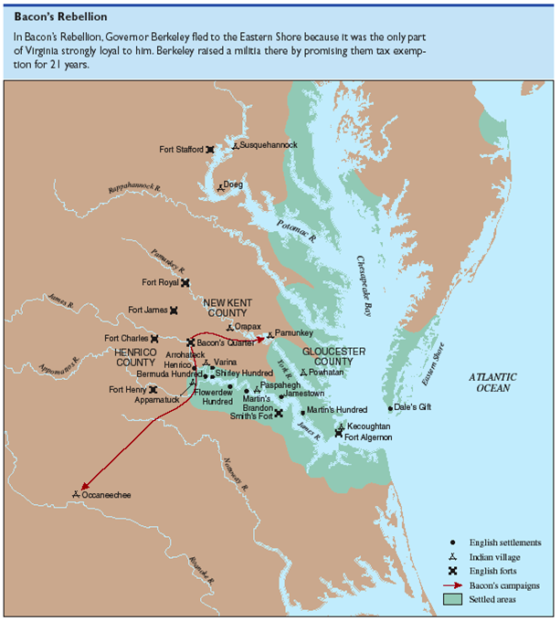
- Nathaniel Bacon became the leader of the frontier settlers
- Bacon felt that the gov’t was being too easy on the Indians
- Bacon also thought that Grandees: elite planters, operated the gov’t for their personal gain
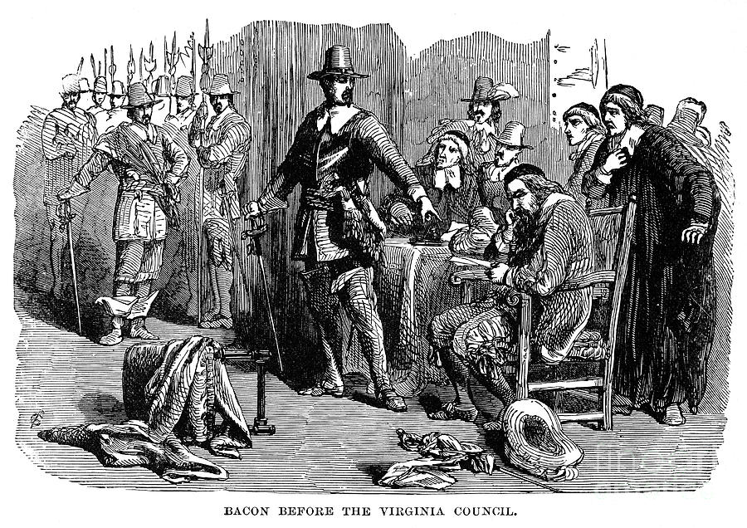
- These officeholders had become wealthy enough to afford slaves as opposed to servants
- 1676 Governor William Berkeley pronounced Bacon a rebel
- Bacon was eventually voted into office
- June 1676 Bacon’s Laws were passed giving settlers more say in gov’t
- Bacon was pardoned and Berkeley authorized Bacon’s Indian warfare
- Elite planters convinced Berkeley that Bacon and his men were a larger threat than the Indians
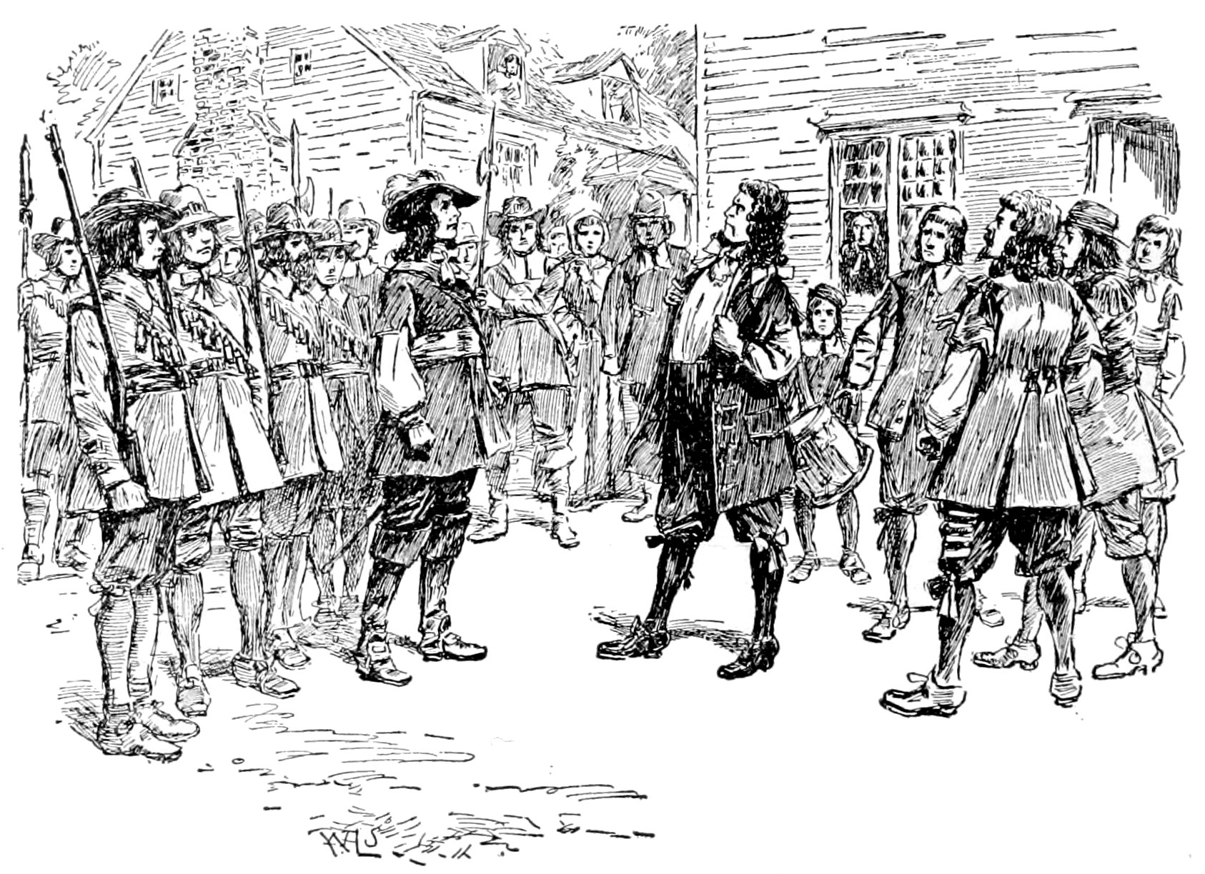
- When Bacon learned he was branded a traitor, he declared war on the grandees
- For 3 months Bacon’s forces fought the Indians, sacked plantations, and attacked Jamestown
- Bacon died October of 1676, probably due to dysentery
- British sent forces to crush the rebellion
Aftermath
- Tensions between great planters and small farmers eventually lessened
- Ruling elite decided fighting Indians was more important that fighting each other
- During 1680-1690 fewer servants arrived in the Chesapeake
- By 1700 the Chesapeake was transitioning to a slave labor system
- Less division between white colonists

