Black Anti-Slavery Activity
- Many white abolitionists didn’t wish to give recognition to black abolitionists of either sex
- AA leaders were active in white societies from the beginning
- Former slaves could speak from firsthand experience
- Frederick Douglass: former slave in MD
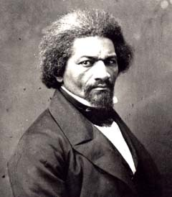
- Became the best known black man in the US
- After a lecture tour in the British Isles, he was able to purchase his freedom
The Underground Railroad
- Occurred when white violence against AA families was increasing in South
- Very secretive
- Slaves escaping from MO, KY, and Chesapeake along predetermined routes
- Escaped slaves from the deep South were less common

- Much more common in the mid 1830s
- Most slaves who escaped did so on their own
- Underground agents were often former slaves, free blacks, and white ministers
- Dangerous to assist escaped slaves
- By early 1850s Harriet Tubman was the best known active worker
- She returned to MD up to 13 times to help slaves escape
Canada West
- Canada was the preferred destination
- Specifically, “Canada West,” present day Ontario
- Slavery was illegal in British empire after 1833
- By 1860 there were 20,000 blacks in Canada West
- Most found work as craftsmen and laborers in Toronto
- Canada provided security, but segregation and discrimination occurred
AA Female Abolitionists
- Sojourner Truth was a well-known female, black abolitionist
- Born into slavery in upstate NY in 1797, freed when NY abolished slavery in 1827
- An 1843 vision of God urged her to travel around the country speaking against slavery
- Her testimony showed the intersection between abolitionism & feminism
Reactions to Abolitionism
- Racism was a national problem in the 19th century
- Even in the North, angry crowds confronted abolitionists
- In 1837 newspaper editor Elijah Lovejoy was killed in IL
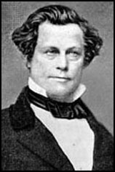
- This gave a martyr to the movement
- He started as a Presbyterian minister in NE
- Later moved to St. Louis
- Lovejoy published a paper that denounced alcohol, Catholicism, & slavery
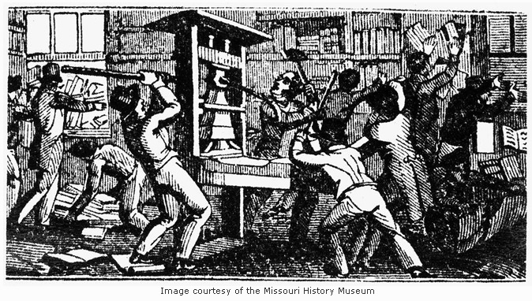
- Lovejoy’s death inspired militants like John Brown to dedicate themselves to the movement
- These militants believed only violence could end slavery

