“Bombingham” in 1963
- Birmingham, AL was called “the most thoroughly segregated city in the US” by MLK
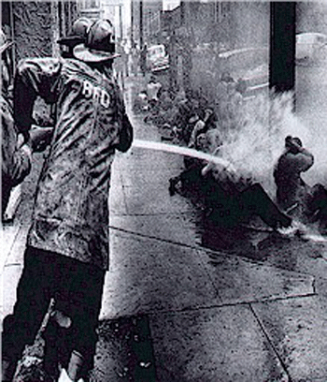
- After Supreme Court rulings, Birmingham closed 8 pools, 38 playgrounds, & 4 golf courses rather than desegregate
- AL Governor George Wallace was a staunch segregationist
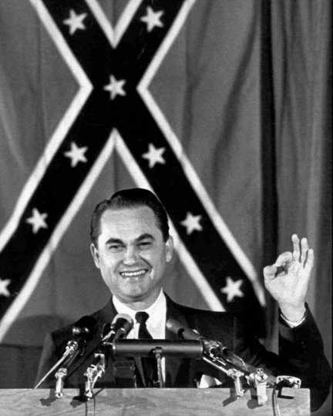
- Birmingham became a target for civil rights groups
MLK & Protesting
- MLK and SCLC announced plans for peaceful demonstrations
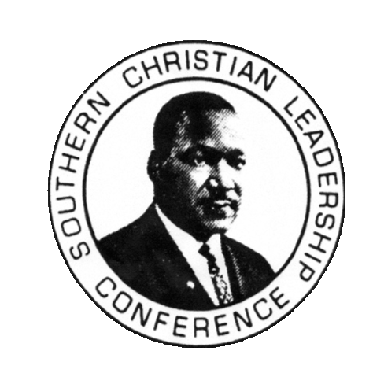
- Marches against segregation took place, mostly young people
- Protesters jailed for not having a permit
- MLK arrested and jailed in April
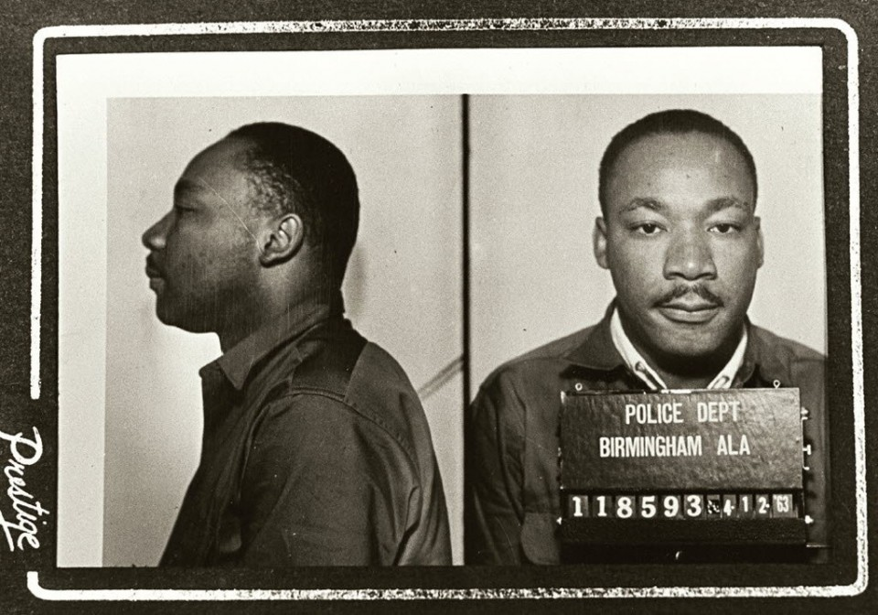
- He wrote “Letter from Birmingham County Jail,” attacking white clergymen asking for patience
- Early May 1,000 AA youth scheduled marches
- Birmingham police chief Bull Connor unleashed police dogs and fire hoses on the protesters
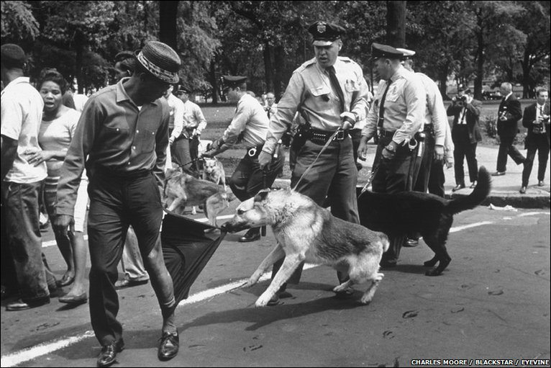
- People around the US and world were shocked
- Over 2,500 arrested that week
- On May 9 Birmingham Chamber of Commerce announced plans to desegregate in 90 days
Violent Response
- May 11 an integrated hotel was firebombed
- MLK’s brother’s house bombed the same night
- Violence increased in the entire South
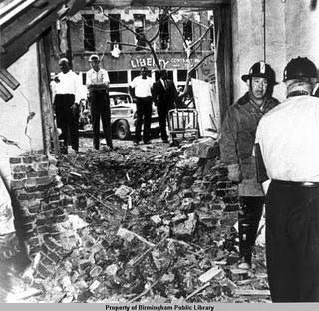
- 9/16/63 the 16th Street Baptist Church was bombed by KKK
- 4 girls killed, 14 other injuries
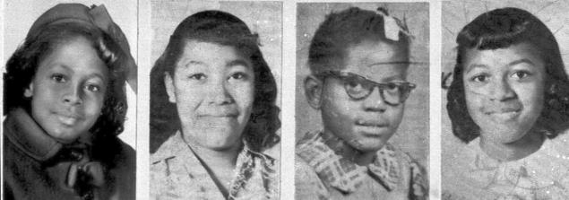
- The same day 2 AA teens shot and killed by police
Impact of Civil Rights Protests
- 10 dead during that year
- 35 AA homes and churches were firebombed
- 20,000 arrests
- Official segregation was finished in Birmingham
