Deadly Urban Violence
- AAs demands for equality led to riots in many cities
- More emphasis on ending racial separation in the North
- Northern cities practiced De Facto Segregation: separation by practice & custom
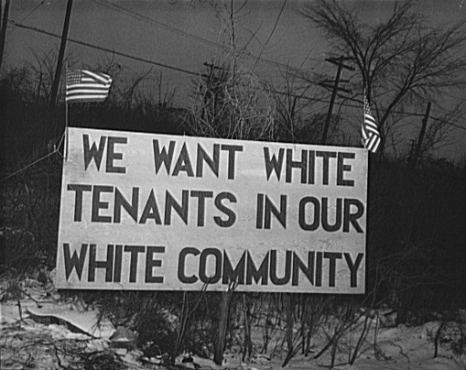
- Southern cities had De Jure Segregation: separation by law
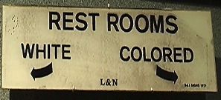
- From 1964-1968 over 100 cities had riots
Detroit Riot of 1967
- One of the most deadly and damaging riot in US history
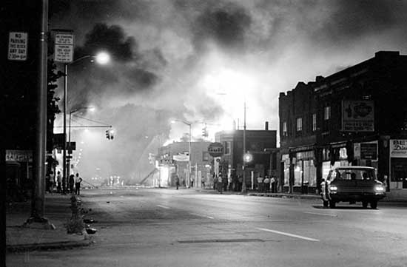
- Lasted 5 days total
- Extensive media coverage
Causes of the Riot
- Police brutality
- Lack of affordable housing
- Urban renewal
- Economic inequality
- Black militancy
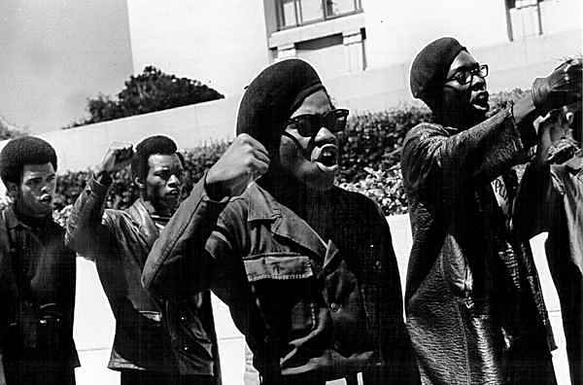
- Demographic changes
How It Started
- Police raided a blind pig: unlicensed after hour club, in an AA neighborhood on Sunday July 23, 1967
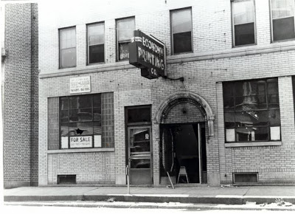
- Found 82 people celebrating a soldier’s return from Vietnam, arrested everyone
- A group surrounded the cops and soon began looting area stores
- As media coverage spread, looting spread to other areas
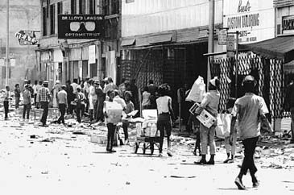
- Soon state police were called in
- Monday alone 483 fires set, 231 total incidents , over 2,500 guns stolen from stores
- On Tuesday, LBJ authorized federal troops as well as MI National Guard troops
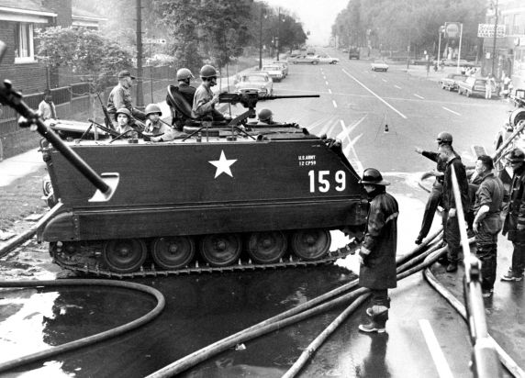
- Troops restored order in 48 hours
Damage Done
- 43 deaths
- 467 injured
- Over 7,000 arrested
- Over 2,500 stores looted
- 410 building destroyed by fire
Impact of Riots
- Lasting image of a city on fire occupied by tanks
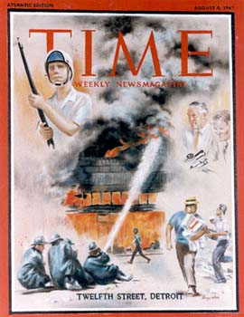
- Increased white flight to suburbs
