Ferguson Unrest
- Protests and riots that resulted from the shooting of Michael Brown in Ferguson, MO
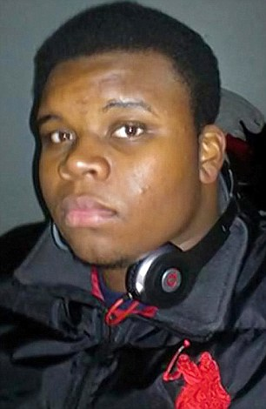
- Shooting occurred Aug. 9, 2014
- Sparked debate about AA/police relations
- Questions about the militarization of police
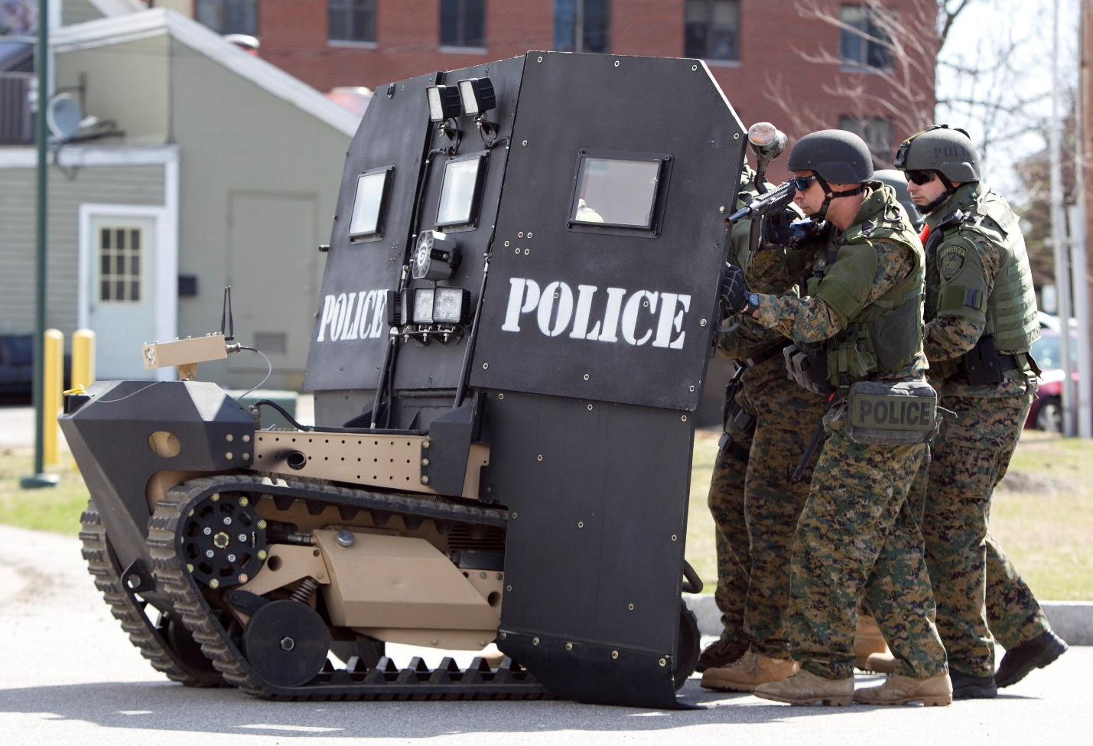
- Debates about police use of force
- Questions about the role of police
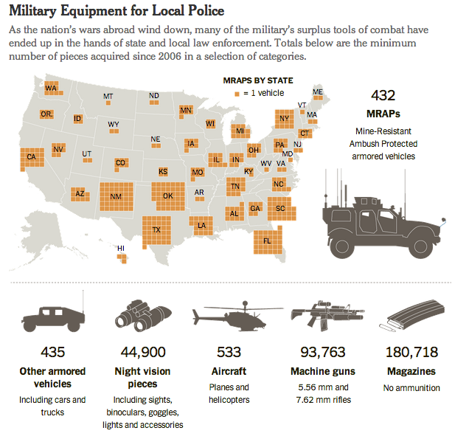
Reaction to Protests
- Police established curfews
- Riot squads maintained order
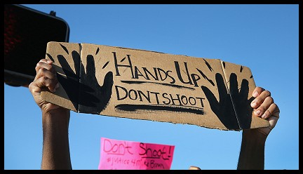
- Some protests were peaceful
- Others involved looting and violent unrest
August 2014
- Police destroyed a memorial to Michael Brown
- Crowd became angry leading to looting
- Quik Trip was burned
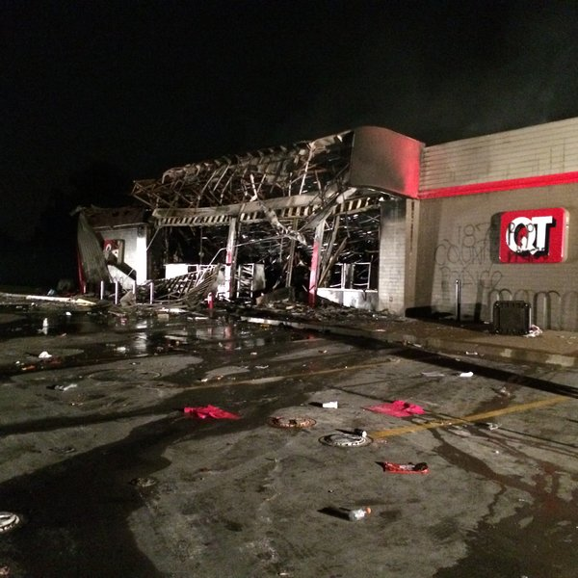
- Tensions continued to mount from Aug. 9-14
- 2 reporters were arrested in a McDonalds
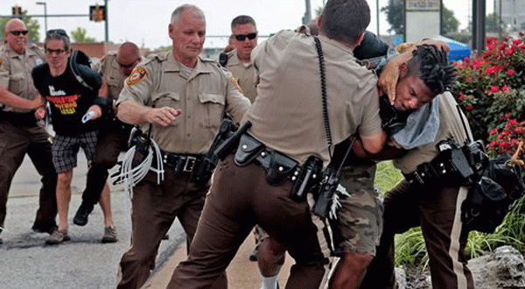
- Some believe that the police attempted to stop the media from reporting from Ferguson
- MO Governor Jay Nixon announced that the state would take over the Ferguson Police
- By Aug. 16 Ferguson was in a “state of emergency”
- National Guard brought in to help restore law and order
Nov. of 2014
- Grand jury would decide whether to indict officer Darren Wilson
- Nov. 24 jury decided to not charge Wilson
- Peaceful protests and rioting ensued
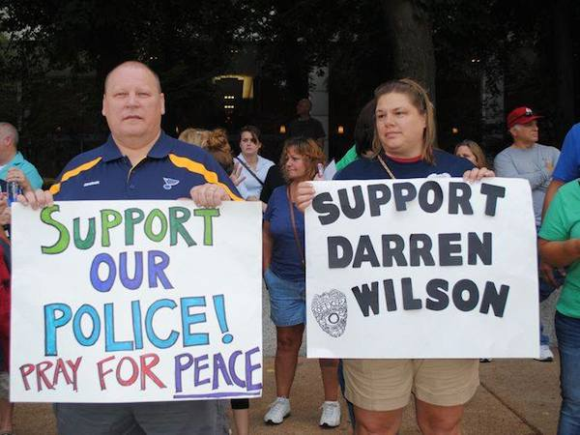
- 170 other US cities had protests
Spring of 2015
- Ferguson police chief Thomas Jackson resigned
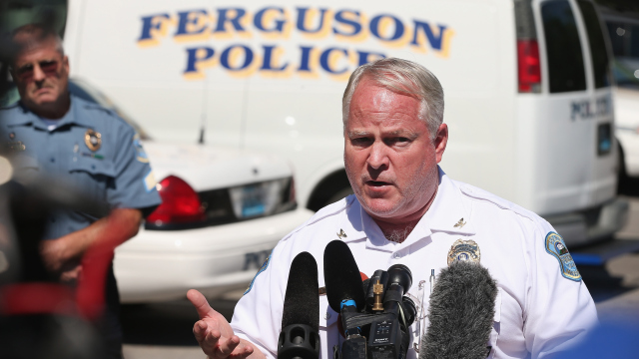
- 2 officers were shot outside of a police station
- 20 year old AA male was arrested in connection to the shooting
- Looting increased after the death of Freddie Gray in Baltimore
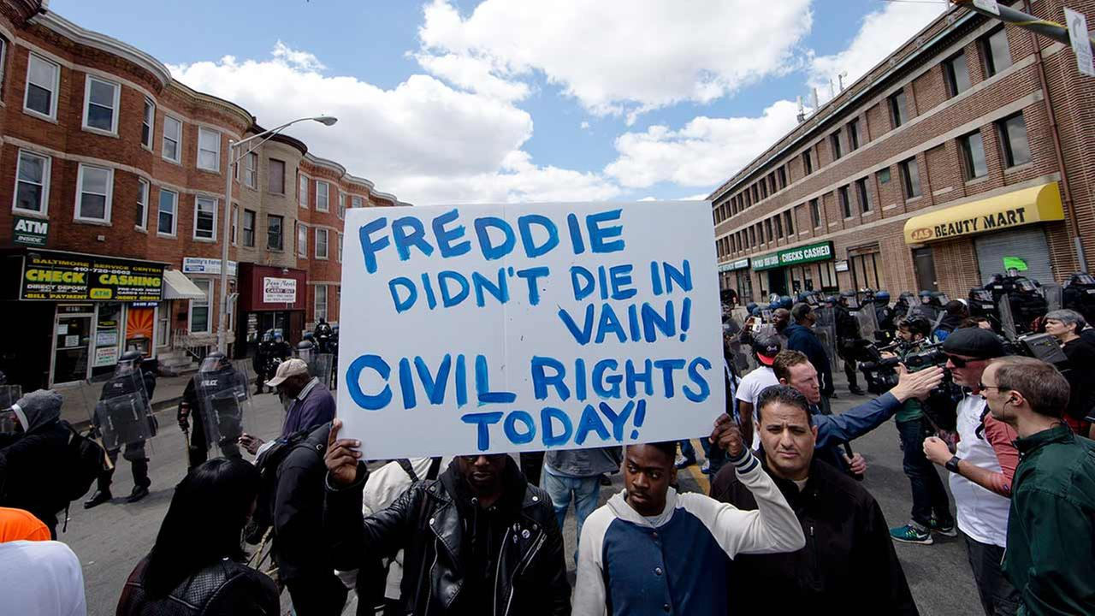
Racial Context
- Long standing distrust between police and citizens in Ferguson
- Many stores that were looted were Asian owned
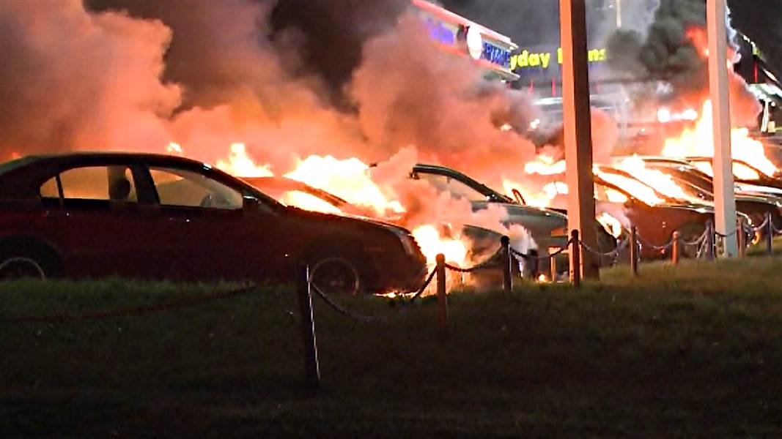
- 48 of the 53 officers in Ferguson were white
- Ferguson population was 2/3 AA
- Police were twice as likely to arrest AAs during traffic stops
- “Suburbanization of poverty”
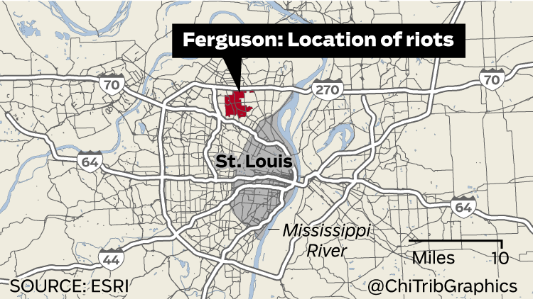

- Time magazine argued that "Blacks in this country are more apt to riot because they are one of the populations here who still need to…”
- Thoughts?
- What about other minority groups?

