Impact of Reconstruction
- The South changed radically during Reconstruction
- Radical Reconstruction changed state gov’t, local sheriffs, school boards, etc.
- Freed slaves and abolitionists gladly filled these roles
Voting in the South
- Jan. of 1870 MS state legislature elected Hiram Revels to the US Senate
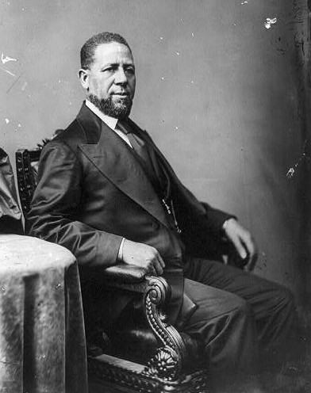
- He became the 1st AA to serve in the Senate
- Revels was born free in NC
- He was a minister that wasn’t initially interested in serving in the Senate
- Revels would fill the vacated seat of Jefferson Davis, former President of the Confederacy
- MS also sent Blanche Bruce to the Senate in 1874
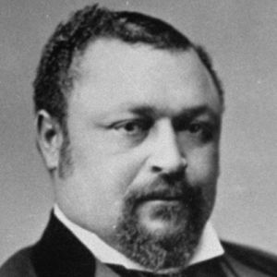
- Bruce was the last AA to serve in the Senate until 1966
- 22 AAs served in Congress during Reconstruction
- Reconstructed state gov’ts expanded the right to vote
- New state constitutions created public school systems

Protecting Civil Rights
- Federal gov’t tried to protect AA voting rights and Republican state gov’ts
- 15th Amendment: a person couldn’t be denied voting rights because of their race
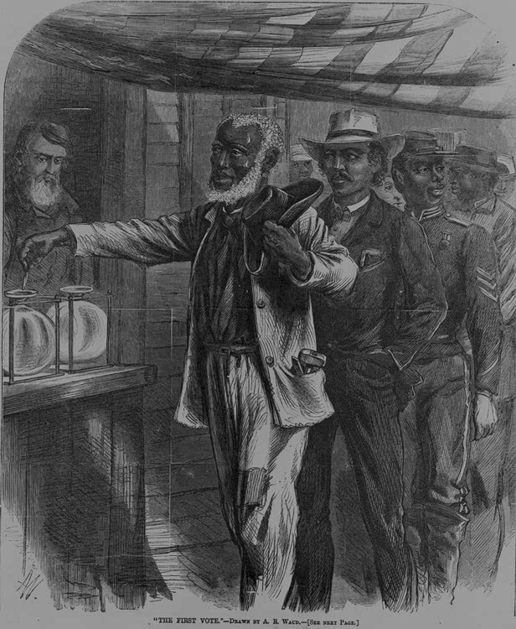
- This didn’t outlaw poll taxes, literacy tests, & property qualifications
- Congress also passed the Enforcement Acts: passed to prevent Ku Klux Klan violence & prevent AAs from being arrested without cause
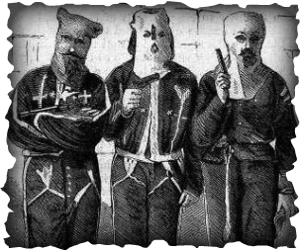
Reconstruction Ends
- The North lost interest in the cause
- By 1877 all federal troops were withdrawn from the South
- Southerners viewed this as “redemption”

