Indian Removal
- Indian Removal was Jackson’s policy of forcing Indians to move to Oklahoma, or Indian territory
- For many white Americans this was seen as a tremendous success
- 5 Civilized Tribes: Cherokee, Chickasaw, Choctaw, Creek, and Seminole that lived in the “Old Southwest” GA, AL, MS, & FL
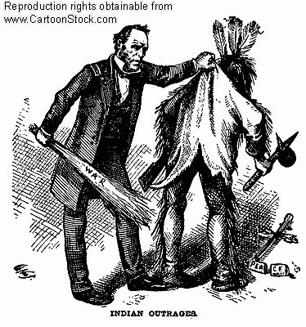
- The 5 tribes adopted many white ways and customs
- Cherokee Nation had a sophisticated political, economic, and cultural institutions
- The Cherokee expected to be treated as a sovereign nation
- Cherokee signed a treaty w the US gov’t in 1785
- They also set up large and effective trading networks w other tribes and white settlements
- In 1827 they adopted a written constitution for the Cherokee Republic
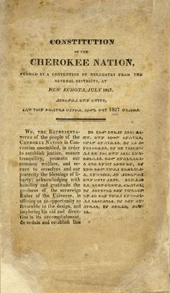
- Some Cherokee grew cotton and had African slaves
- This assimilation was exactly what the US gov’t claimed to want
- President Jackson chose to ignore this and were focused on taking Cherokee land
- GA was the first state to ignore prior treaties starting in 1830
- Indian Removal Act: Legislation passed that provided funds for removing & resettling eastern Indians to the West
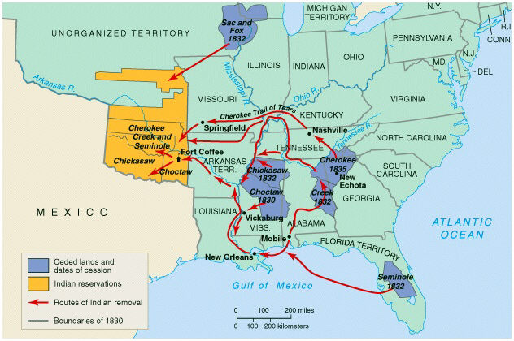
- Initially Cherokee tribes were given a choice
- Stay, and be subject to GA law
- Move west and their independence would be recognized in the Indian Territory
- Not every gov’t official supported moving natives
- Some wished to recognize the treaties that had been in place for 50 yrs
- Within the decade most tribes made the trek from their native lands to Oklahoma, except for Seminoles
- AL and MS followed GA’s lead and voted to end tribal rights for Creeks
- Trail of Tears: 12,000 members of the Cherokee tribe forced march from GA to Indian Territory
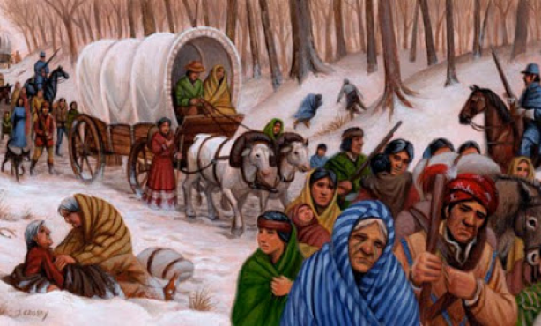
- Winter of 1838-1839 was unseasonably cold, leading to 1/3 of Cherokees dying
- Approximately 46,000 Indians were forcibly removed during Jackson’s administration
- Subsequent Presidents removed even more Indians
- Cherokee Nation is located in NE Oklahoma today
- They are the largest federally recognized tribe
