Nativism & the Klan
- Many Americans wished to cap 20th century immigration
- Gained strength in years prior to the war
- Immigration became associated w/radicalism
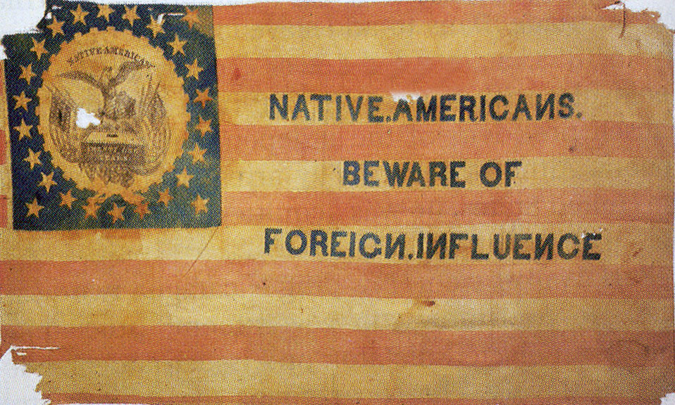
- Emergency immigration act was passed in 1921
- Immigration couldn’t exceed 3% of the number of that nationality who were in the US in 1910
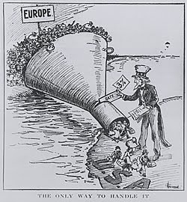
- Immigration fell from 800,000 to 300,000
- National Origins Act of 1924: banned immigration from east Asia
- Euro immigration would be reduced to 2%
- Quota based on 1890 numbers, which had much fewer E. and S. Euros
- Further restrictions capped immigration at 150,000 total

The New Klan
- Leo Frank, Jewish factory manager, was found guilty of murdering a female employee (1915)
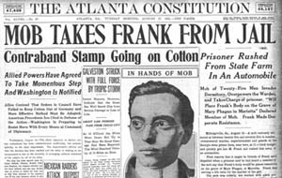
- Nativists stormed the jail and lynched Frank
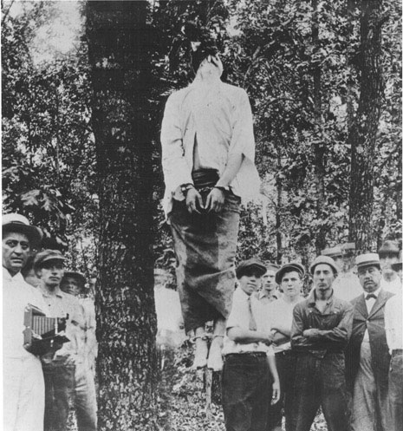
- DW Griffith’s film Birth of a Nation further inflamed nativists
- The new Klan targeted “insubordinate” AAs at first
- After WWI, Catholics, Jews, and immigrants became targets
- Klan membership spread quickly to Northern industrial cities
- By 1924 the Klan had over 4 million members
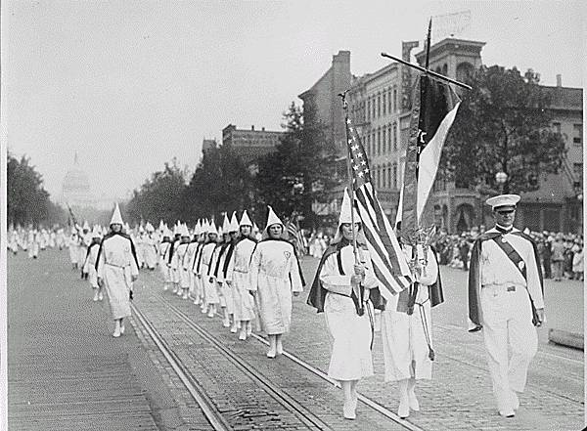
- Klan members portrayed themselves as patriots and community leaders
- Klan feared anything seen as posing a challenge to “traditional values”
- Klan wished to enforce prohibition
- They also pushed for compulsory Bible reading in schools
- Klan membership declined after 1925
- David Stephenson brought negative attention to the Klan
- The Klan was effectively dead by WWII

