The O.J. Simpson Case
- OJ Simpson was a Hall of Fame football player and an actor
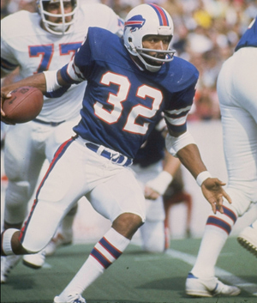
- Arguably the most publicized trial in US history
- More airtime was given to the case than the Bosnian War and Okla. City bombing combined
- At the trial’s end, there was a racial divide on Simpson’s guilt
The Crime
- June 13, 1994 Simpson’s ex-wife, Nicole Brown Simpson, and her companion were brutally murdered
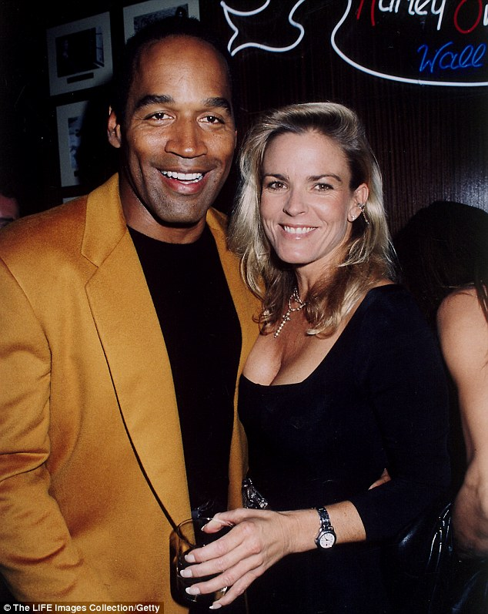
- The Simpson’s had been divorced for 2 years
- Evidence found at the crime scene linked OJ to the crime
- Lawyers convinced the LAPD to let OJ turn himself in
- Simpson never showed, and was later spotted on a freeway in a white Bronco
- The infamous “slow chase” ensued as Simpson threatened suicide
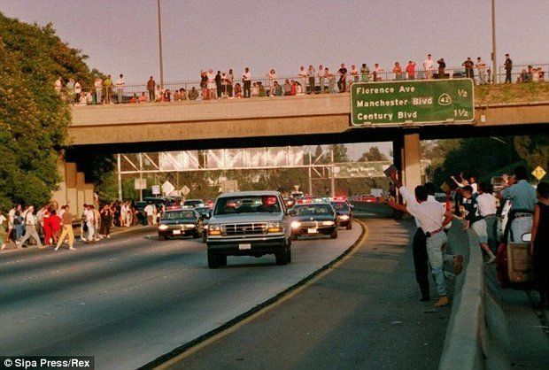
- 95 million Americans watched as all news outlets covered the chase live
- Many LA citizens lined the street to catch a glimpse of the vehicle
- He was eventually apprehended and arrested
The Trial
- Due to the amount of media coverage, many participants became celebrities
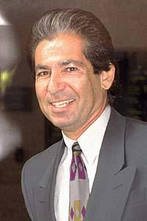
- Simpson spent between $3-6 million on a “Dream Team” of attorneys
- Began Jan. 24, 1995
DNA Evidence
- DNA evidence gave prosecution confidence in a conviction
- Matches were found between OJ’s blood and bloody shoe prints found at the scene
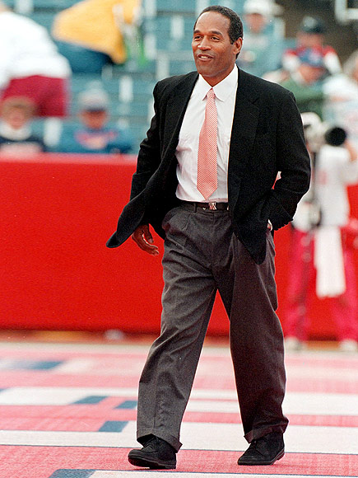
- The technician that handled OJ’s blood sample held onto it for nearly a day before turning it over for testing
- This led to doubt about the police’s ability to deliver reliable results
Mark Fuhrman
- Police officer who found blood at OJ’s residence
- Was portrayed as a racist by the defense
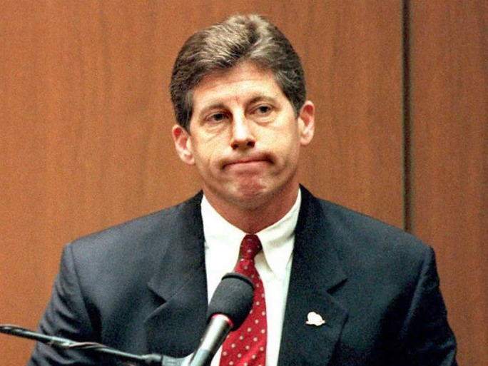
- Tapes later surfaced that contained Fuhrman using a racial slur multiple times
- Defense used this to question his credibility
The Glove
- A glove containing blood from both victims and OJ was found at his estate
- OJ was asked to try the glove on and it didn’t fit
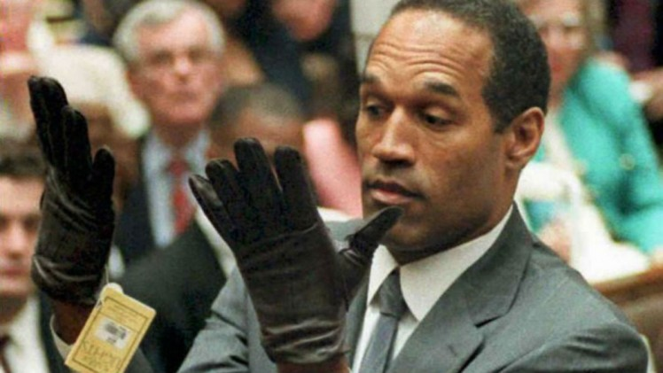
- “If it doesn’t fit, you must acquit!”
The Verdict
- 100 million people worldwide waited for a decision
- Preparations were made nationwide in case of rioting
- Oct. 3, 1995 the jury returned with a verdict of not guilty
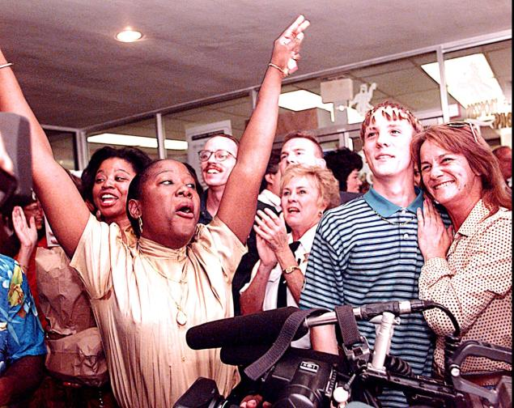
- In a civil trial OJ was found guilty of wrongful death and forced to pay over $45 million to families of victims

