The Birth of the Texas Republic
- After the LA Purchase, the W. border of the territory was disputed
- Spain insisted the border the was Sabine River (TX/LA border)
- Jefferson wished that the Rio Grande River was the border
- In the Adams-Onis Treaty of 1819 the Sabine was recognized as the border
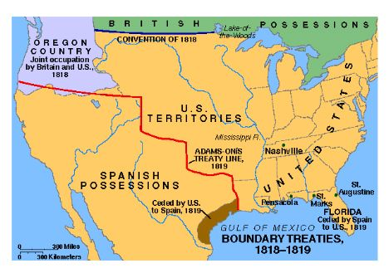
- Mexico gained independence from Spain in 1821
- The revolution lasted from 1810-1821, ruining Mexico’s economy
- Tensions between Americans living in Texas and Mexico increased

Early Settlers
- Spanish gov’t had originally let Missourian Moses Austin set up a colony
- They wished to stabilize the border
- Stephen F. Austin came to build the settlement
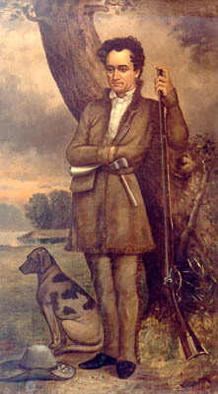
- He swore loyalty to the new Mexican gov’t
- Austin became an Empresario: agent getting a land grant in return for organizing settlements
- Few Euros or Mexicans moved into TX
- People of Spanish or Mexican descent born in TX were known as Tejanos
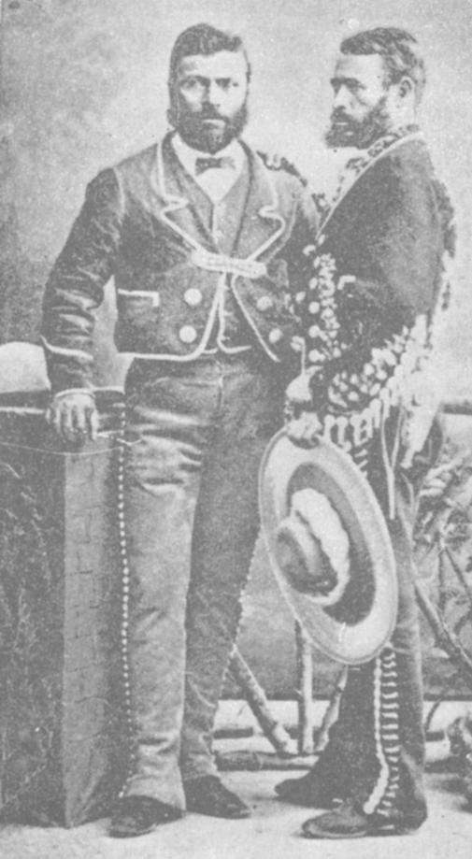
- Americans came in large numbers
- By 1830 20,000 American settlers came w 2,000 slaves
- Mexico had abolished slavery in 1829
- TX was officially ruled by Mexico, but lived by American rules due to an unstable Mexican gov’t
- American immigration into TX was ended in 1830
- Mexico also insisted that all trade had to go through established ports in Mexico
- By 1833 Americans in TX wished to have autonomy from Mexico
- An army under the control of Sam Houston was raised
- Texan independence really began in 1835
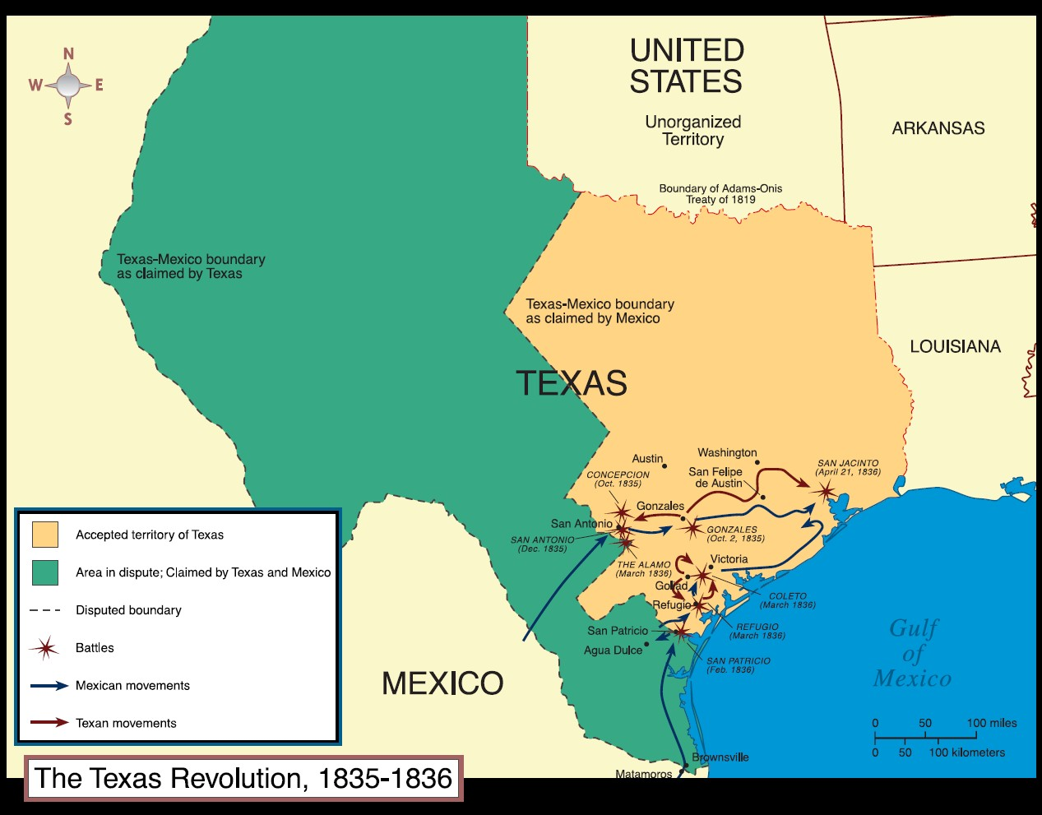
- The Alamo was captured by American forces late in 1835
- Mexican forces regained the Alamo in March of 1836, with 200 defenders being killed
- “Remember the Alamo!” became a rallying cry for Texan independence
- A constitution was drafted in 1836 with Sam Houston being elected president
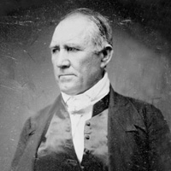
- Houston wished for TX to be annexed into the United States
- Some in Washington DC were worried about adding a large slave state
- TX was officially recognized as an independent republic

