The Black Panther Party
- Most institutionalized expression of Black militancy
- Huey Newton and Bobby Seale created the party
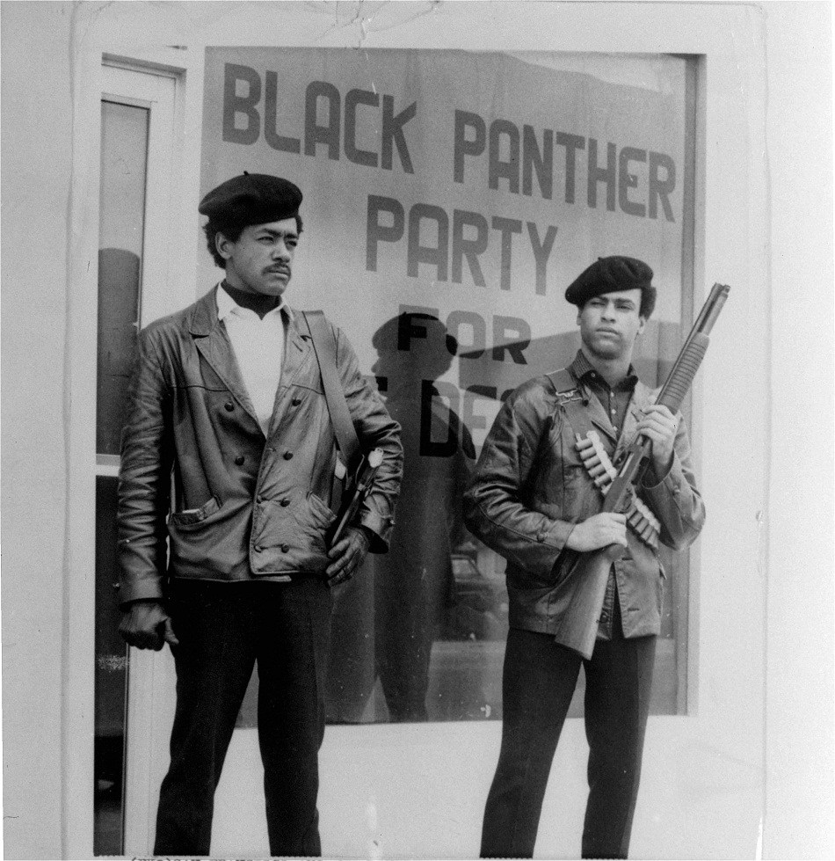
- Took the symbol of the Lowndes County Freedom Organization (LCFO)
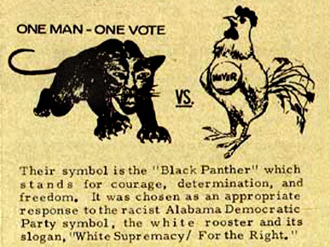
- Combined Black Nationalist ideology with Marxist ideas
- They hoped to overthrow capitalism and end police brutality
- Stokely Carmichael became aligned with the Panthers
- Eldridge Cleaver became the Panthers’ minister of education
- He was a follower of Malcolm X
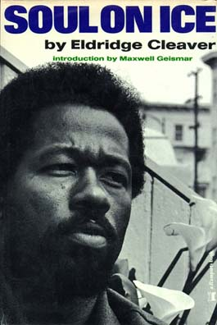
- Wrote autobiographical essays that became Soul on Ice in 1968
- Cleaver believed AAs were victims of colonization and need to be liberated
- Cleaver fled into exile after a police shootout in Oakland
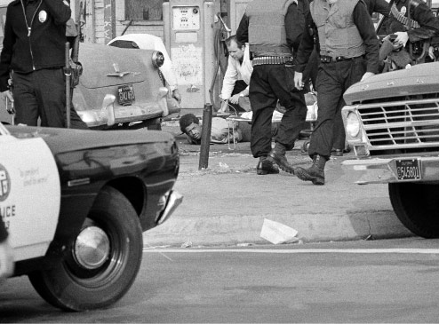
- He later abandoned radicalism and became involved with the Republicans
“Power to the People”
- Organized health care programs
- Free breakfast
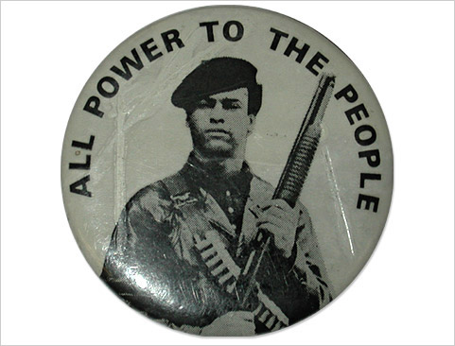
- Lectured to instill racial pride
- Educated youth about Black History
- Launched some of the earliest drug education programs
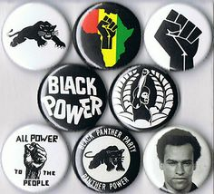
Police and COINTELPRO
- Panthers alarmed many white Americans
- Panthers took up arms to patrol neighborhoods to monitor police
- FBI director J. Edgar Hoover determined to harass the Panthers
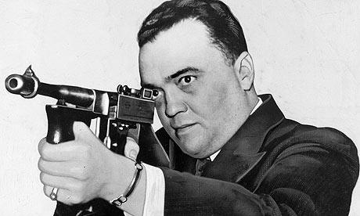
- Purpose was to gather counterintelligence on black nationalist groups
- Undercover agents infiltrated the Panthers
- Helped provoke violence and mayhem within the party
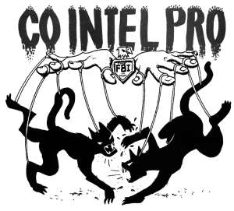
- Shaped negative perceptions of Panthers
- Law enforcement killed 28 Panthers
- 750 others were incarcerated
