The First Gulf War
- Saddam Hussein invaded Kuwait in Aug. of 1990
- Kuwait had raised oil production
- This was in violation of an OPEC agreement
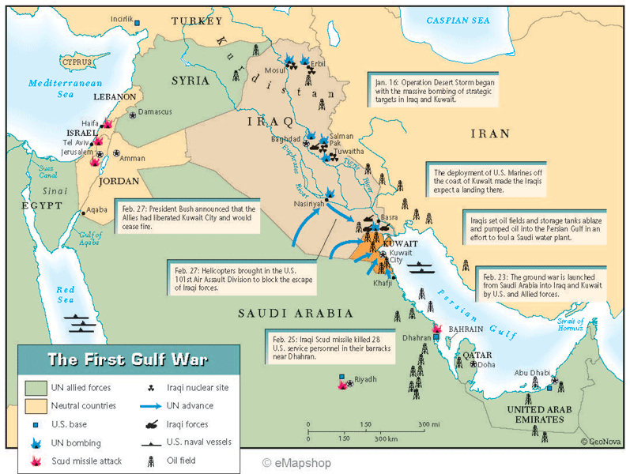
- Resulted in a drop in global oil prices
- Iraq was deep in debt from the war with Iran
- Hussein was surprised at the backlash the Kuwaiti invasion caused
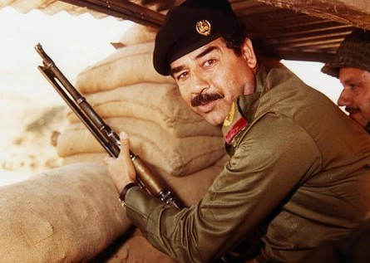
- UN enacted a trade embargo on Iraq
- President Bush dispatched troops and planes to Saudi Arabia
- British and Arab forces joined
- Operation Desert Shield: mobilization of American reserve forces to stabilize the region
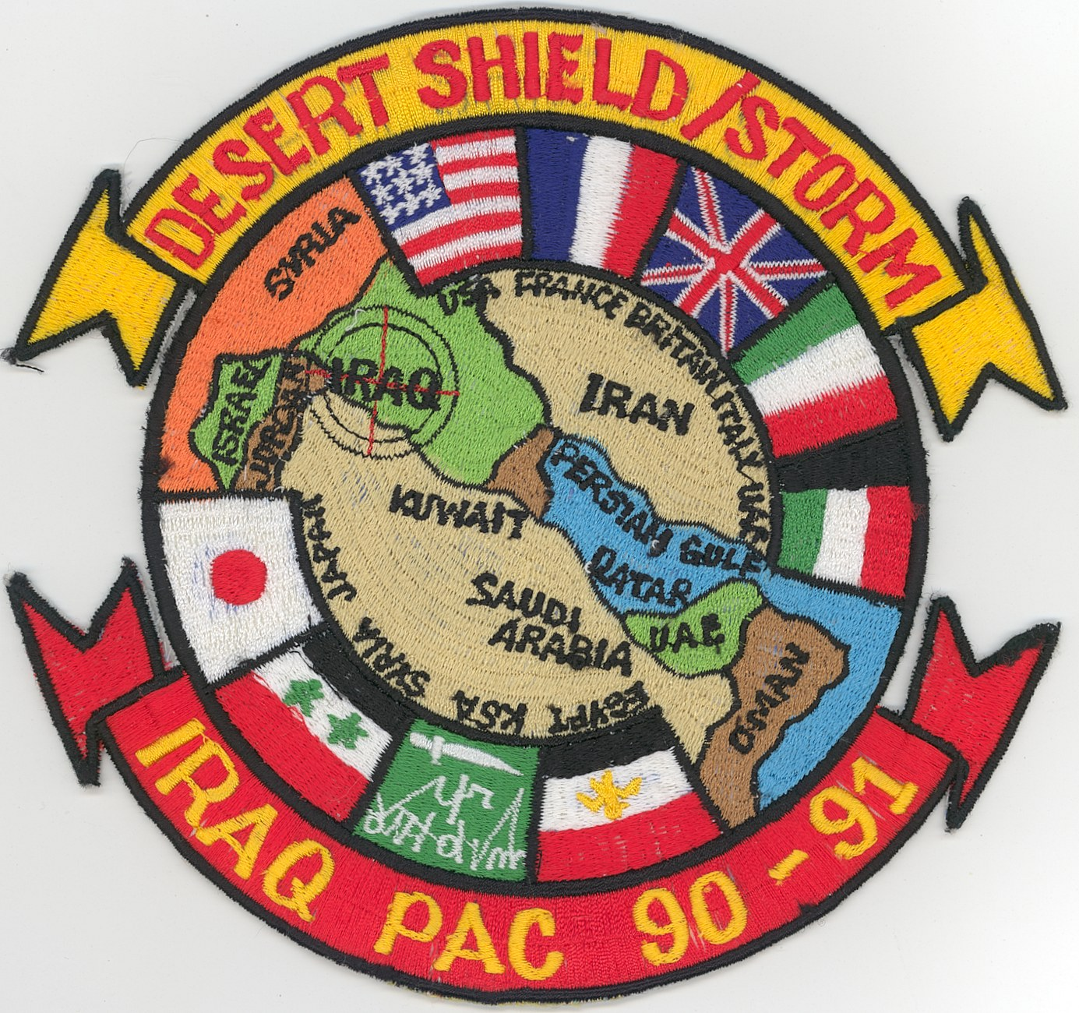
- Peace efforts went nowhere
- Jan. of 1991 Congress authorized armed forces to liberate Kuwait
- 16 other nations committed ground troops to Operation Desert Storm
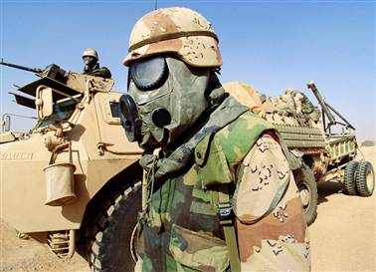
- First allied cruise missile hit Iraq on Jan. 16
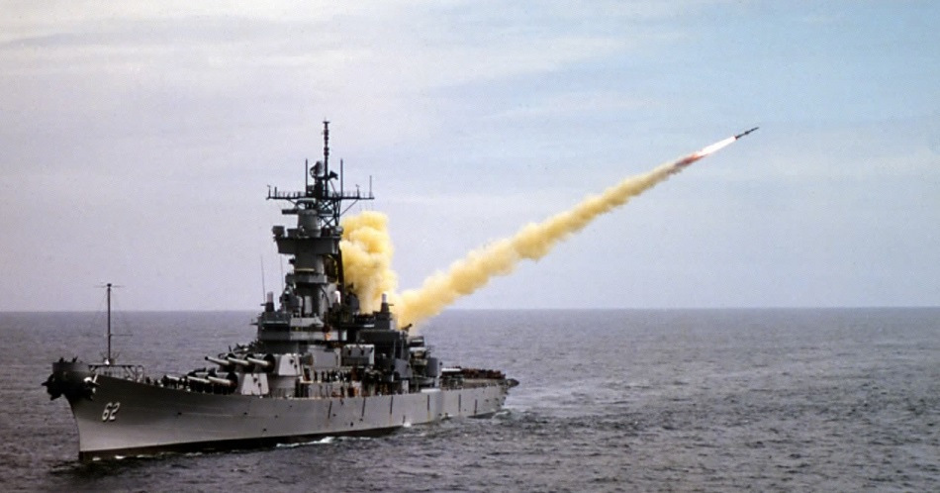
- Allied ground assault lasted 4 days
- Iraqi soldiers surrendered by the thousands
- Cease fire called after 6 weeks
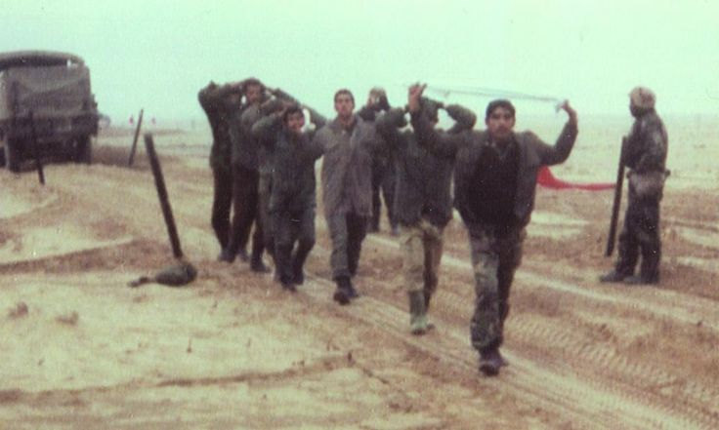
- 137 American casualties
- Over 100,000 Iraqi casualties
- The Hussein regime remained intact
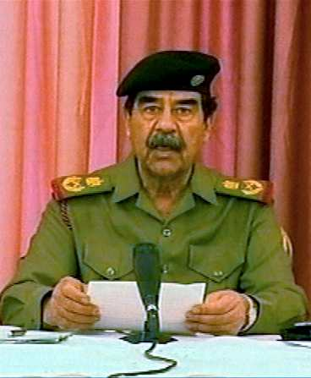
- Hussein referred to the conflict as the “mother of all battles”
- Some Arabs were humiliated by the defeat
- This would spiral into a new war on terrorism

