The Great Awakening
- Religion was central to 18th century American life
- Colonial printers produced more religious works than anything else
- 1730s religious revival among Presbyterians and Congregationalists
- Mostly a New England and middle colonies phenomenon
- Ministers emphasized the need for a “new birth” through religious conversion
- Jonathan Edwards (MA) one of the most well-known pastors of the era
- Edwards preached about God’s grace and eternal damnation
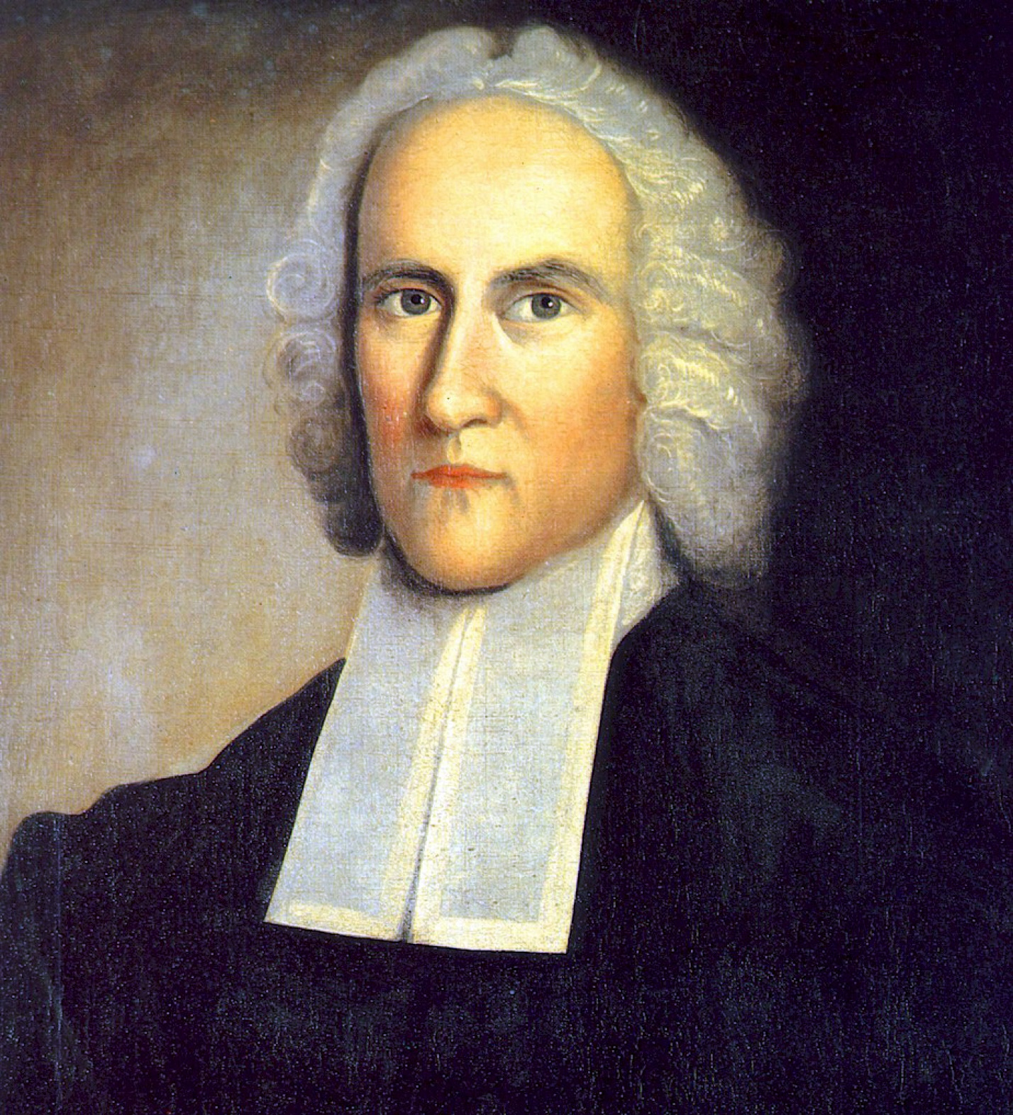

- George Whitefield created huge religious fervor in 1739
- British minister travelled the colonies preaching to large crowds over a 2 yr. period
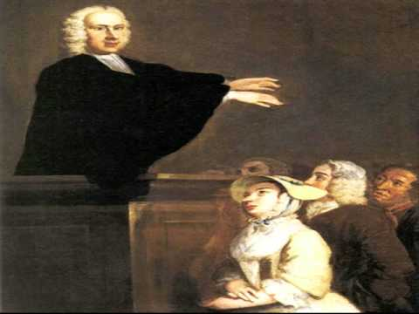
- He turned churches into a type of theater
- Dramatic gestures, lots of emotion, etc.
- These performances were popular with all groups
- Thousands of “awakened souls” joined old churches or formed new ones
- Whitefield became a type of religious celebrity
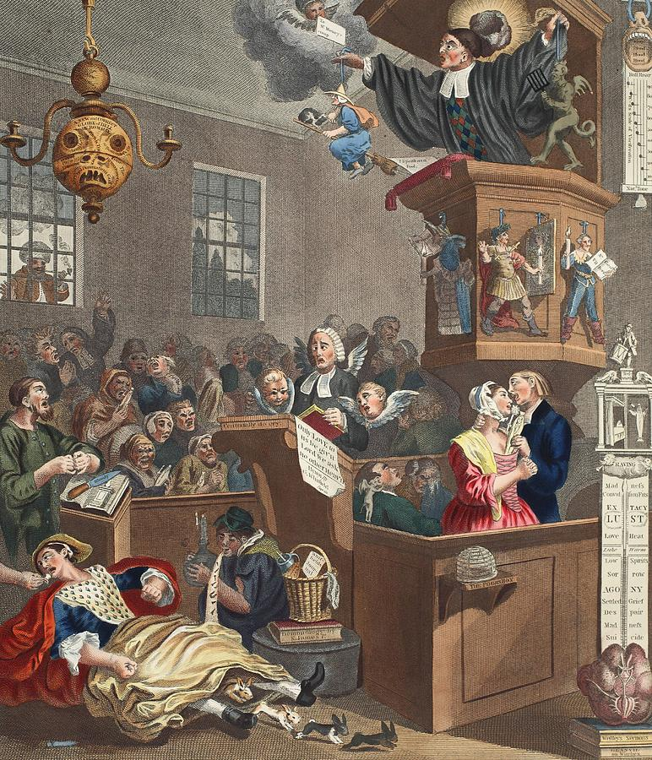

Great Awakening Aftermath
- Many awakened church members criticized ministers
- Popular ministers began going from town to town
- Colonials became more divided along religious lines
- Baptists were the biggest champion of the Awakening
- Many Presbyterian and Baptists churches began in the South
- Americans were constantly at odds: religion, ethnic & racial divides
- Divides between coastal and backcountry cultures
- Old Lights: religious traditionalists
- New Lights: religious revivalists
- New church members became defenders of religious freedom
- This should not be restricted by the gov’t

