The Plantation World: A Slave Society
- All British colonies had slaves in the late 1600s
- Bacon’s Rebellion forced the planter elite to consolidate their power
- Slavery was seen as better alternative to indentured servants
- Slavery would now be inherited and permanent condition: Chattel Slavery
- Slavery would now dominate all aspects of Southern colonies
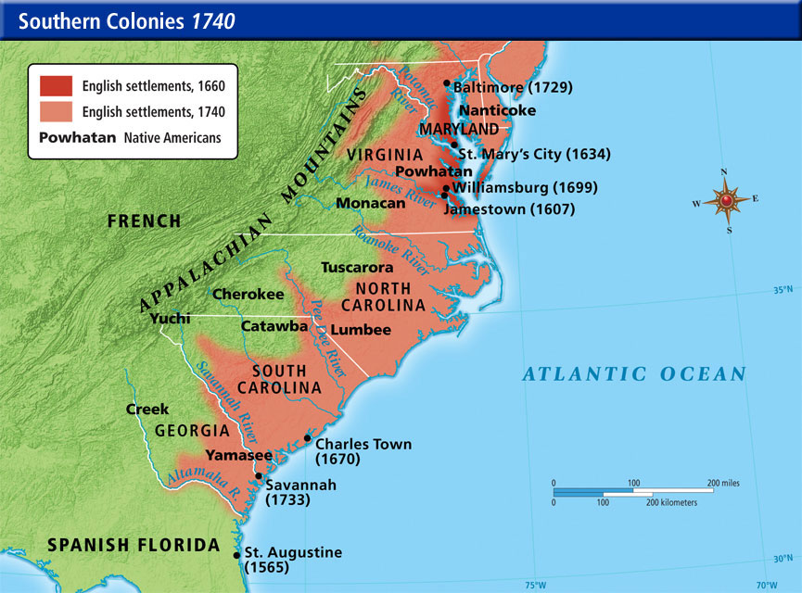
- Slavery was designed to bring colonial stability
- Slavery was now linked directly to race
- Indians were often excluded from colonies
- Children of mixed race were marginalized
- Any child born to an AA woman was considered African
- By 1700 most tobacco & rice workers were African slaves
The Atlantic Slave Trade
- N. American slavery was a small % of the Atlantic slave trade
- Most slaves were sent to sugar plantations in Brazil & Caribbean
- 10-15 million slaves came across the Atlantic between 1500 and 1900
- Middle Passage: voyage from W. Africa to the Americas
- Known for its horrible conditions
- 25% would die over the 7 week trek
- 1st generation slaves were almost exclusively from W. Africa
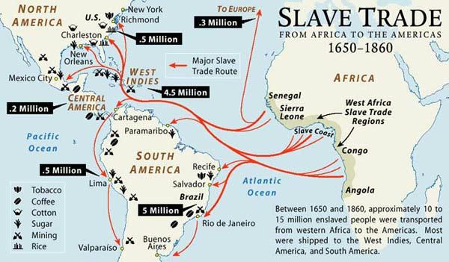
- Slaves were stripped of their self-dignity
Rebellion
- Slave revolts threatened the status quo
- Stono Rebellion: largest slave uprising prior to the American Revolution
- Slaves could escape to freedom in FL, Spanish territory
- SC authorities restricted slaves’ rights to meet as a result
- Increased tensions between GB and Spain

Tensions in NYC
- NYC and Providence had large concentrations of slaves
- Urban slavery not as backbreaking
- Fires swept through NYC in 1741
- Governor George Clarke blamed slaves
- Prosecutors brought charges against 30 Africans, most being slaves, and 4 whites
- They were executed, hanged or burnt at the stake
- 84 other suspects were sold into slavery in Jamaica
- Those who enslaved others feared reality

