The Second New Deal
- Lasted from 1935-1936
- Needed because improvement didn’t happen as quickly as FDR wanted
- No longer just focused on economic recovery
- FDR remained popular as he was re-elected in 1936
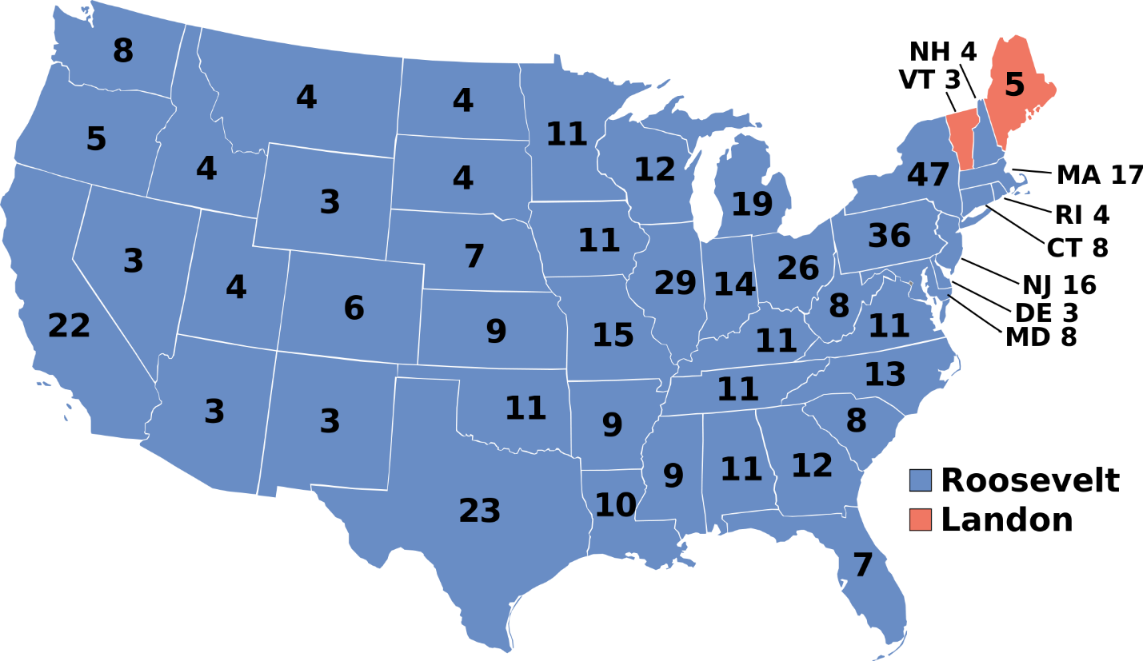
Helping Farmers
- Soil Conservation & Domestic Allotment Act: farmers were paid for not planting soil depleting crops
- Also rewarded for good conservation practices
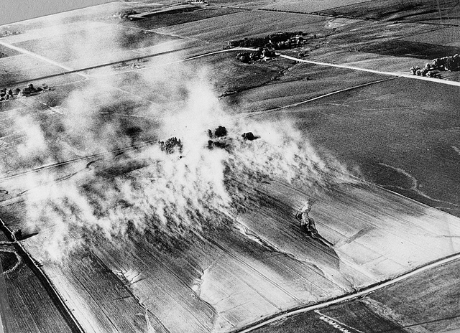
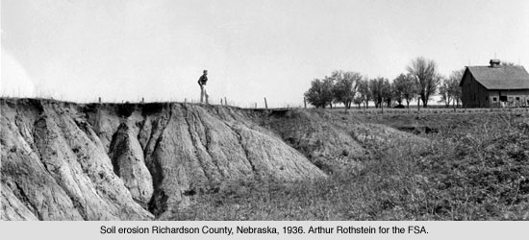
- Money was provided to sharecroppers, migrant workers, etc.
Works Progress Administration (WPA)
- Goal was to provide lots of jobs quickly
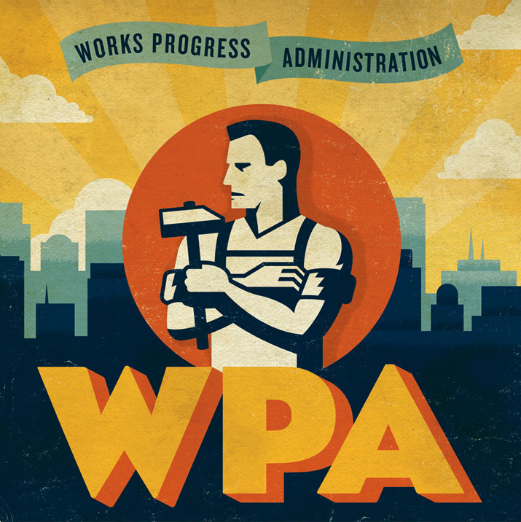
- 1935-1943 spent $11 billion to create 8 million jobs
- Built public buildings, airports, roads, etc.
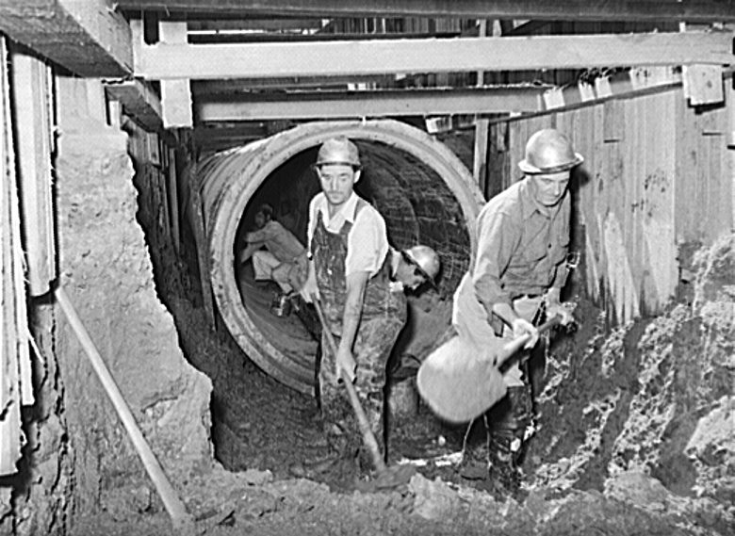
- Provided many jobs for people in the arts
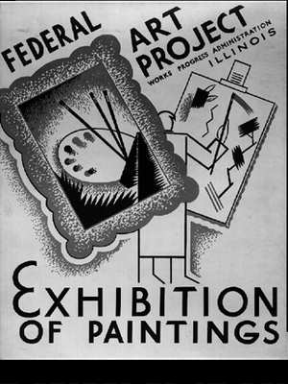

Social Security Act
- Retirement for citizens 65 and older
- Unemployment compensation was started by taxing employers
- Aid to the disabled who couldn’t work
Rural Electrification Administration
- Emphasized electricity for farmers
- In 1935 12% of farms had electricity
- 90% of farms had electricity by 1949
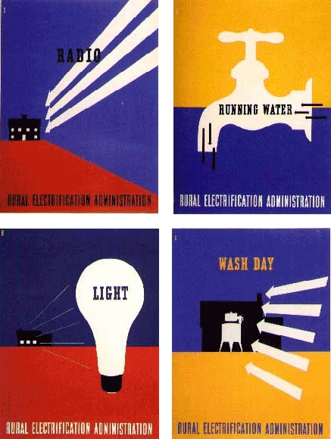
Environmental Benefits
- Policies put in place to protect natural resources
- National parks system started
- Tennessee Valley Authority (TVA): built dams in TN to create electricity and create jobs
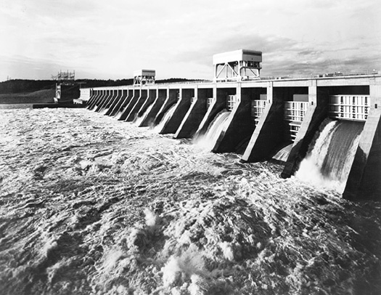
The Wagner Act
- Most important piece of labor legislation
- Gave workers the right to unionize and negotiate w/ employers
- Employers couldn’t interfere w/ union activities
- More than 70% of Americans favored unions by 1937

