The 2nd War in Iraq
- The overall goal was to fight terrorism
- Consists of 2 major phases
- First phase was to remove Saddam Hussein’s Ba’athist government from power
- Second phase was fighting the insurgency that opposed the new gov’t
- Two sects of Islam (Shia and Sunni) would make the second phase difficult
Reasons for Invasion
- US and British officials believed that Iraq possessed weapons of mass destruction
- Iraq was said to have an active biological weapons program
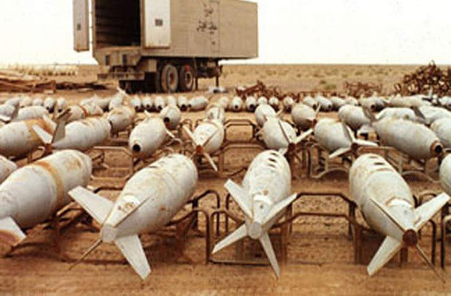
- Hussein had allegedly used poison gas on civilians
- Hussein was thought to be an al-Qaeda supporter
- France and other nations were opposed to invading Iraq

The Invasion
- March 20,2003 the surprise invasion started
- War was never declared
- Coalition forces were met with opposition
- April 24, Baghdad, Iraq’s capital, fell to coalition forces
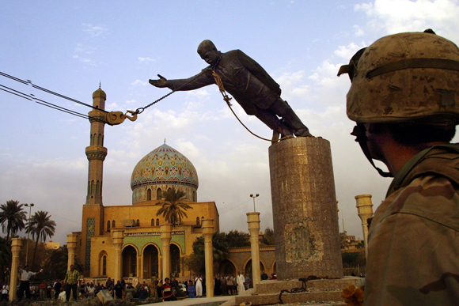
- Hussein’s 24 year reign was over
- Widespread crime and looting followed the fall of the regime
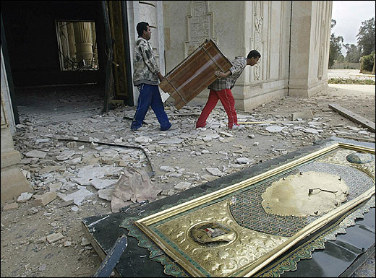
- 17,000 Iraqis died during the invasion, compared to 139 Americans
- Bush delivered a “Mission Accomplished” speech
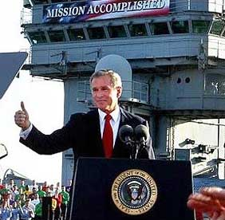
Beginnings of Insurgency
- Nation building proved to be impossible
- Fall of 2003 it became clear that US troops would have to remain for years
- Insurgents used guerrilla tactics, IEDs, and roadside bombs against US forces
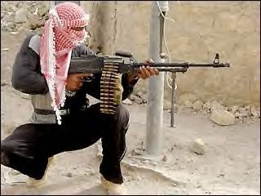
- Suicide bombs wreaked havoc on Iraqi citizens and coalition forces
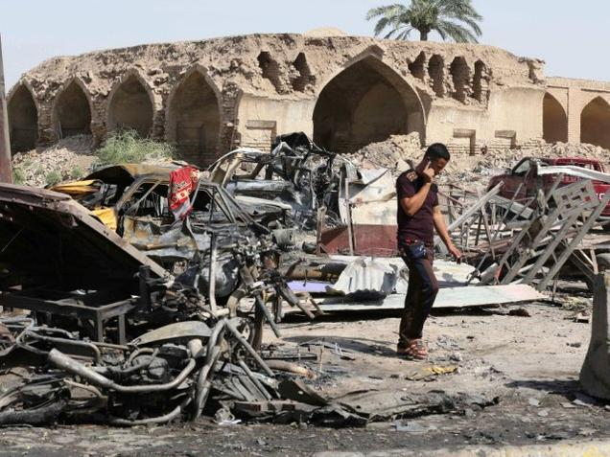
- US forces focused on capturing former gov’t officials
- Saddam Hussein was eventually captured
Second Battle of Fallujah
- Fallujah was a known stronghold of insurgents
- March 2004 four US military contractors were ambushed and killed by insurgents
- Their corpses were burned and then hung from a bridge
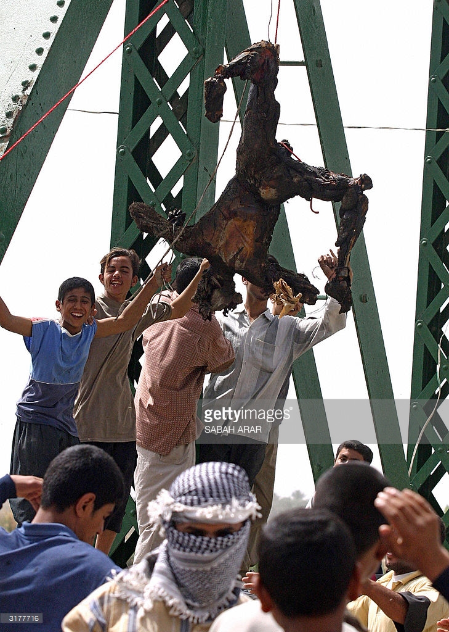
- Photos surfaced enraging Americans
- 46 day battle
- Bloodiest battle of the war, with over 1,300 insurgents killed and almost 100 Americans
- Later released that the coalition may have used chemical weapons
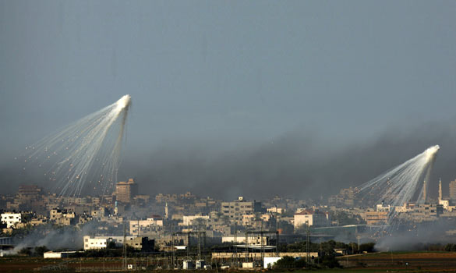
- By Sept. 2004 US deaths in Iraq reached 1,000

Building a New Government
- Elections were held in 2005
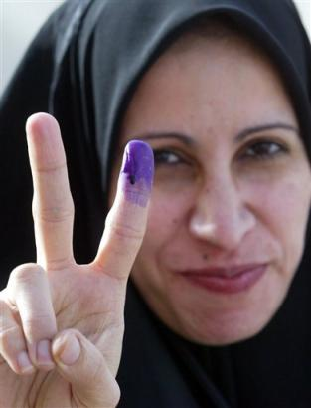
- Elected gov’t took office in May 2006
- Hussein was executed December 2006 for crimes against humanity
The “Surge” of 2007
- From 2007 a civil war was being fought between Sunni and Shia insurgents
- Led to a US troop surge in Jan. 2007
- Total would be almost 170,000
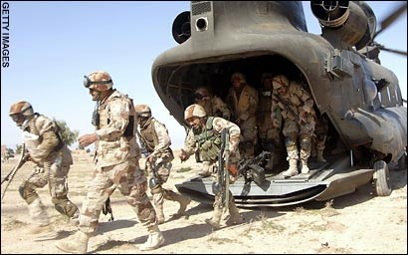
- Successful from a military perspective
- Surge failed in its political objectives
- In 2008, US deaths passed 4,000
- Bush said the conflict was “longer and harder and more costly than anticipated”
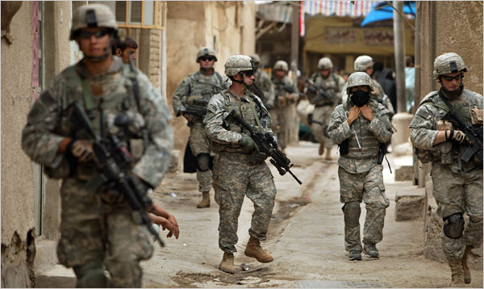
Withdrawal from Iraq
- August 2010 US announced plans to withdraw combat troops
- All combat troops were gone after December 2011
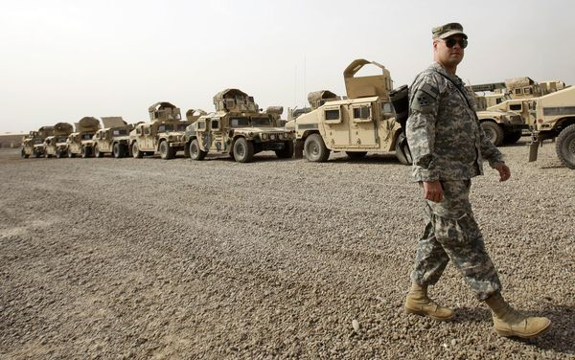
- Iraqi insurgency increased after the US’s departure
- 4,500 Americans killed and 25,000 wounded
- 190,000 Iraqis killed with 130,000 being civilians
- Cost the US almost $2 trillion
- Iraq is still unstable today

