US War in Afghanistan Background
- Intervention in Afghan civil war after 9/11 attacks
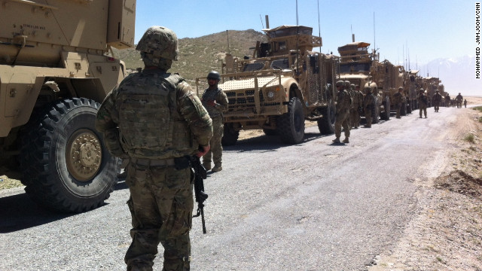
- Goals were to dismantle Al-Qaeda: an Islamic terrorist organization, and to remove the Taliban: an Islamic fundamentalist regime, from power
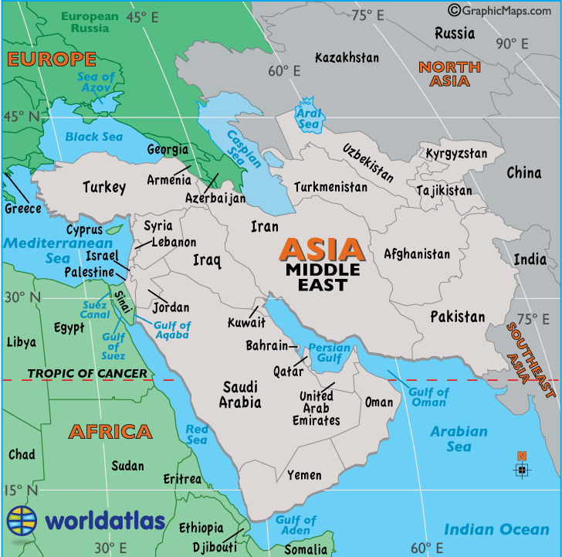
Soviet/Afghan War
- Soviet version of the Vietnam War
- Soviets had superior weaponry, but no home field advantage
- War fought from 1978-1992 between the Mujahidin: anti-Communist Muslims and Afghan/Soviet forces
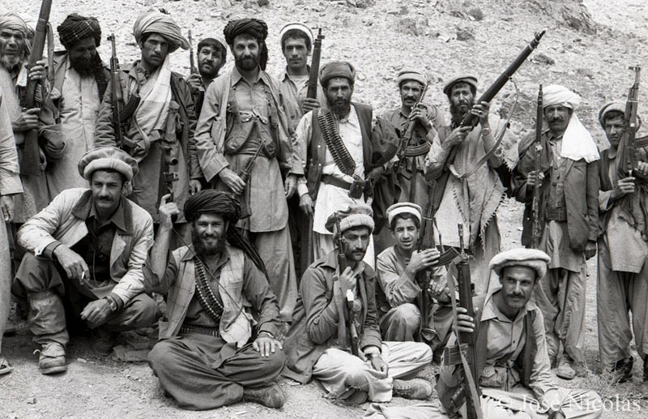
- Soviets wanted a Communist gov’t in Afghanistan
- US responded by supporting Muslim rebels
- Soviets widely controlled the cities, while the rebels controlled the mountainous countryside
- Soviet presence angered many Afghans and led them to support the Mujahidin
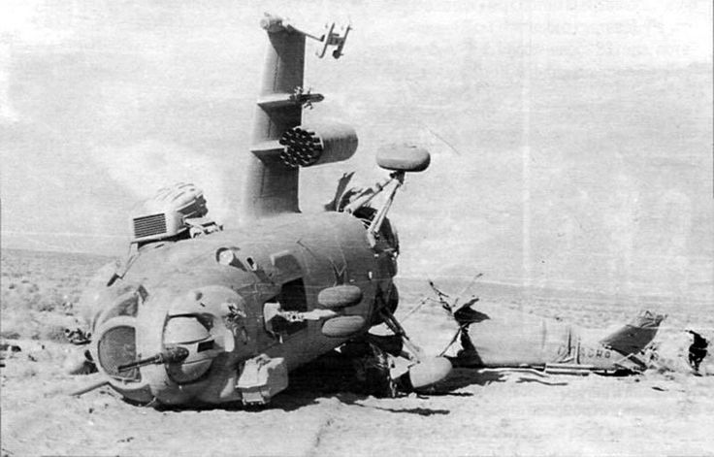
- The war was a stalemate, thus Soviet forces withdrew
- This led to a divided nation, setting the stage for the Taliban to seize power
Impact on Afghanistan
- 5 million became refugees in other nations
- Much of the land was destroyed
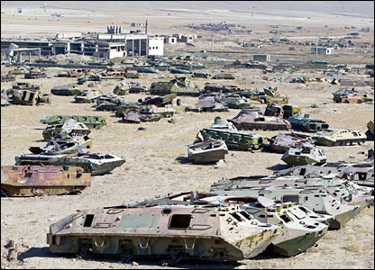
- Soviets left hundreds of thousands landmines behind
- Al-Qaeda was able to operate in Afghanistan
- Mujahidin leaders were unable to unite the various groups within Afghanistan
- Different areas were controlled by various warlords
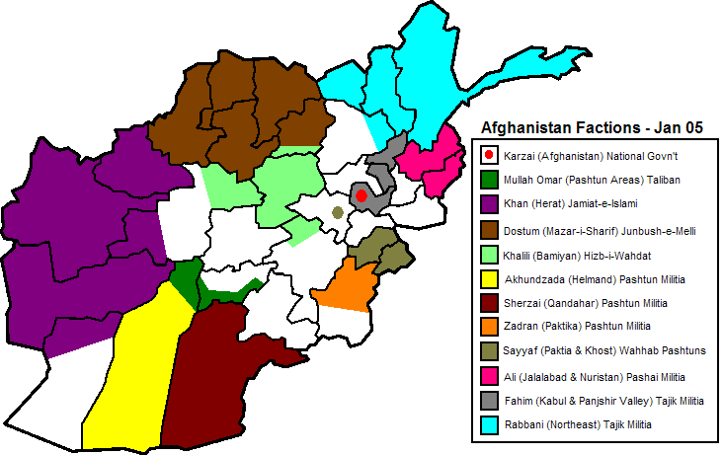
- This led to a divided nation, setting the stage for the Taliban to seize power
The Taliban
- Taliban means “students”
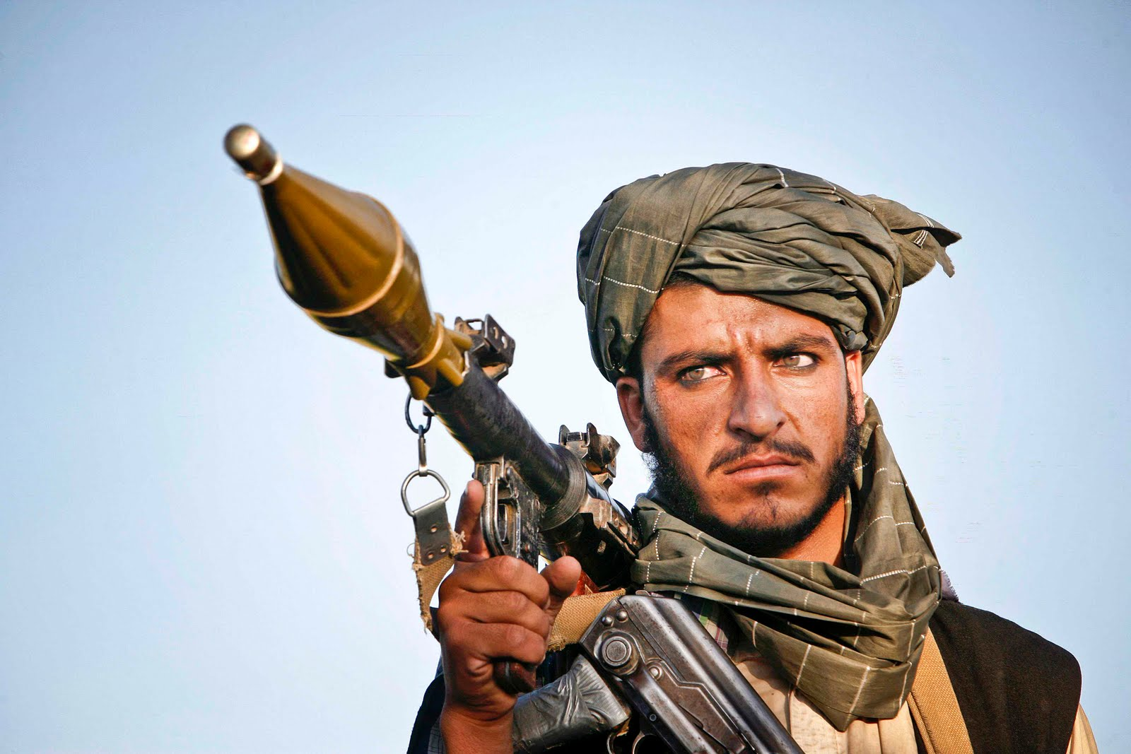
- Ruled Afghanistan from 1996 to 2001 with support from Pakistan
- Believed in strict interpretation of Islamic law
- Known for being incredibly brutal to women
- Women were forced out of school and faced death if educated
- Responsible for countless deaths due to ethnic cleansing
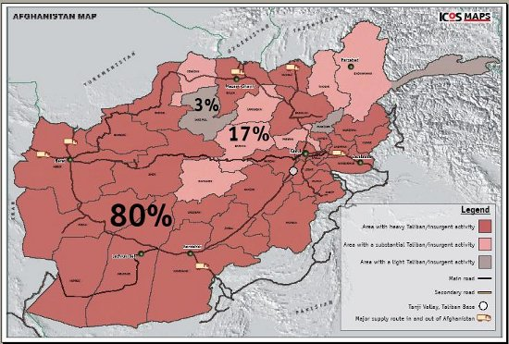
- US supported the Taliban prior to 1996, as they were anti-Iranian

